GIT

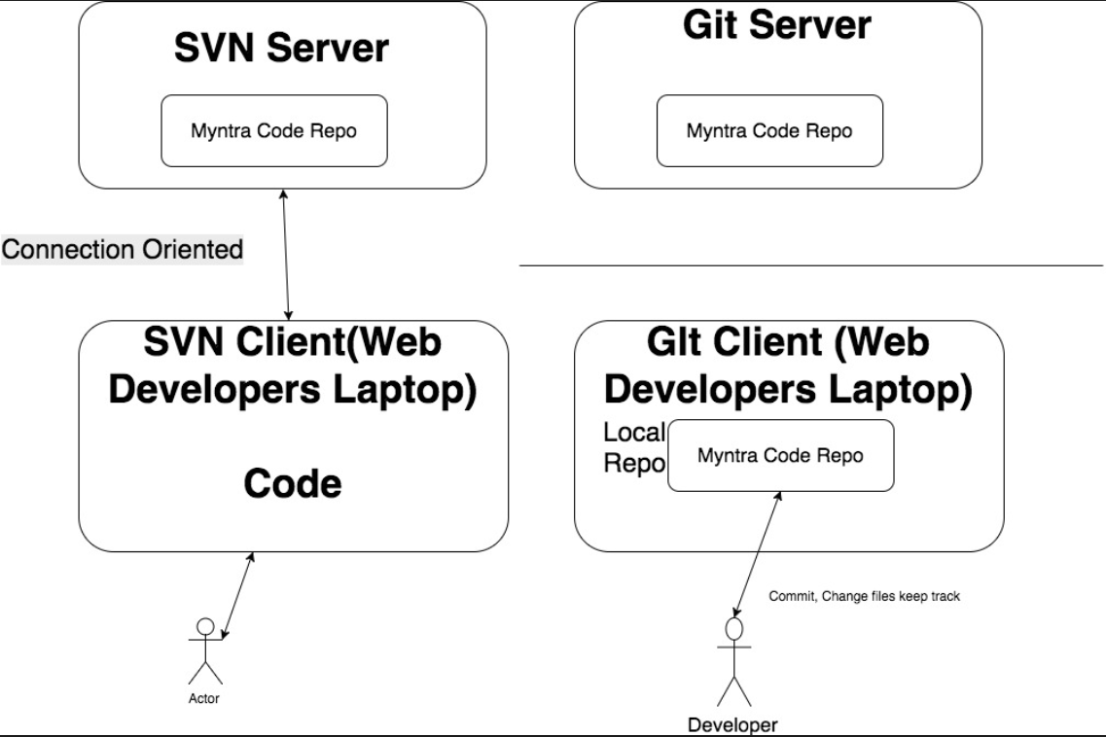

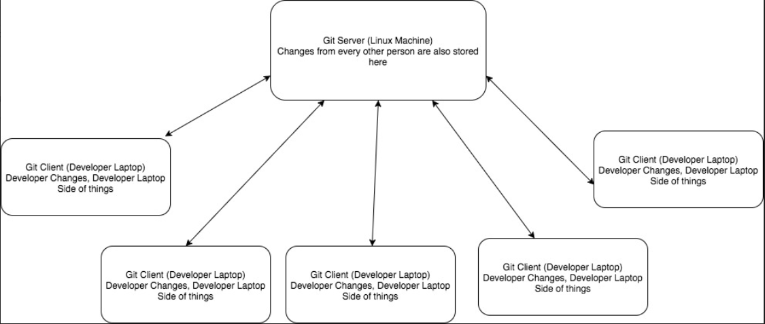

Difference between SVN and GIT

SVN has one central repository, but GIT has multiple repositories, one central repository but each developer has their own repository.

With SVN if the central repository goes down or the code has broken the build then no other developers can commit their code until the repository is fixed. With GIT as each developer has the own repository it doesn't matter if the master repository is broke they can continue to commit code locally, until the master repository is fixed and then they can push their code into the master repository.

Another benefit of having a local repository is that it is quick, there is no network traffic needed to commit code into source control, developers can work in isolation until ready to push the code to the master repository

When your feature is complete and you are ready to merge your changes back into the master repository you need to push your changes from your local repository to the master repository. This is the slowest part of using GIT and is the same as a commit in SVN, but as you won't be doing this as often as a commit using GIT is very fast.

### SVN

Svn contains below things.

### Trunk

This area is where your stable code will live, no one should ever commit broken code into the trunk as this is the central area where everyone working on the project will get updates

### Branches

As explained above a branch is used when you want to create a new feature, so you branch the code from the trunk. Advantage to use branch is to make sure that trunk remain stable.

### Tags

A tag is a way of marking your code as a certain point in time, it is the same as branching your code.

The time when tags are used is for deployments, when your new code is finished, merged into the trunk, has been fully tested and ready to be released this is when you will tag your code

Gitlab setup and installation

GitLab Installation strategy overview

1. Download repository from git lab site
2. Install gitlab
3. Configure gitlab

**Details**

Prerequisite Once the new ubantu machine is setup

1. Perform the below command

*apt-get update && apt-get dist-upgrade -y*

1. change the machine name in /etc/hostnames

Once the above is done, follow the steps given in below URL

<https://about.gitlab.com/installation/#ubuntu>

1. Install and configure the dependency with the below command

apt-get install curl openssh-server ca-certificates postfix -y

1. Add the git lab package repository

curl -sS https://packages.gitlab.com/install/repositories/gitlab/gitlab-ce/script.deb.sh | sudo bash

1. Once the repository is setup by above command. Run the below command to update it
2. apt-get update –y
3. Now we can search the gitlab in the apt cache with the below command (optional)
4. Apt-cache search gitlab-ce( with this search command you can search any software in apt cache)
5. Now install the gitlab with the below command
6. apt-get install gitlab-ce
7. The above command just install the basic gitlab with the below message “It looks like git lab has not been configured yet”
8. The above basic installed can be confimed by going into /etc/gitlab
9. Now before doing the remaining installation of gitlab, first do the reconfiguration of gitlab like below
10. Check the IP of the machine (example 192.168.169.5)
11. Now go to the below location and change the **external_url and replace the site url to ip address like external_url ‘http://192.168.169.5’**
12. Vim /etc/gitlab/gitlab.rb
13. Now re-configure the gitlab with the below command
14. **gitlab-ctl reconfigure**
15. Once gitlab is reconfigured, check the status with the below command
16. /opt/gitlab/bin/gitlab-ctl status ( the same can be used to start, stop gitlab)
17. Now Gitlab is up and running, go to the above ip address in IE and configure the new password
18. Here in this case the username for github is **root** and password is **redhat123**

GitLab Roles and responsibilities

1. Can setup/install gitlab server on any host machine like ubantu/centOS or on cloud EC2 instances of ubantu/centOS from scratch single hand idly.
2. After install , can set up all the configuration in GIT lab like creating group/user defining permission levels to user etc.
3. Can import/migrate the code repository from any existing version control system like SVN, github to Gitlab and get the business going forward from there.

**Import/Migrate code repository from github to gitlab**

1. Login Go to github 🡪 setting 🡪 personal access tokens🡪 generate a new personal access token(this token is like password)🡪 select all scopes
2. 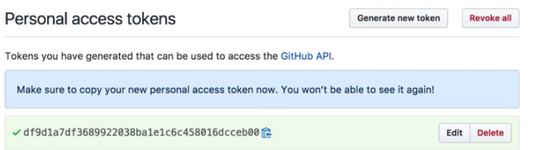
3. Now go to gitlab and groups 🡪 new project 🡪 import from git hub-🡪 give access token generated🡪 and import

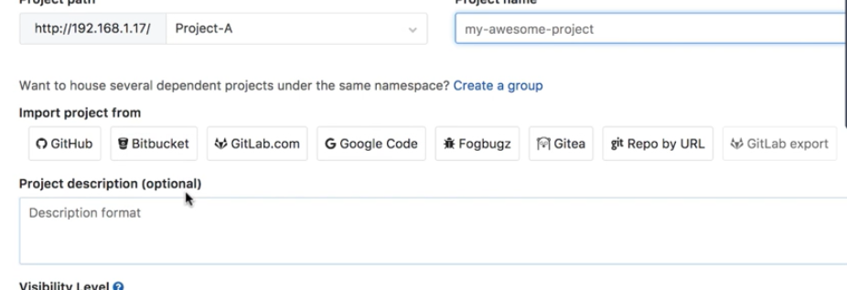

++++++++++++++++++++++++++++++++++++++++++++++++++++++++++++++++++++++++++++++++++++++++++++++++++++++++++++++++++++++++++++++++++++++++++++++++++++++++++++++++++++++++

GIT-HUB download and setup

***Prerequisite – download VM ware hyprviser esxi as github is heavy setup and cannot be run in vm hosted on Oracle VM box ( note – vmware esxi is equivalent to Oracle vm box. esxi is used on large servers in data centres)***

***First install vmware workstation( esxi will work only the workstation not directly on windows)***

1. Go to Enterprise github site (<https://enterprise.github.com/>)
2. Download the license

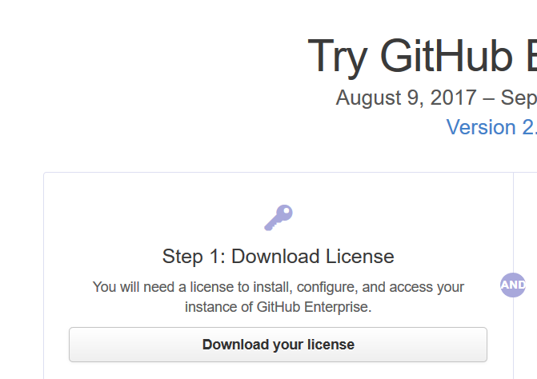

1. Now download the github OVA file
2. 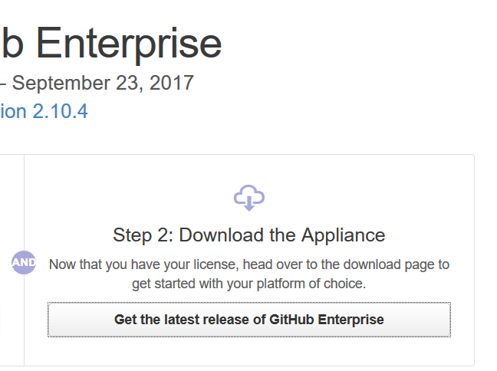
3. Download the vmware exsi github OVA its 1 gb file( for cloud download the different one)
4. 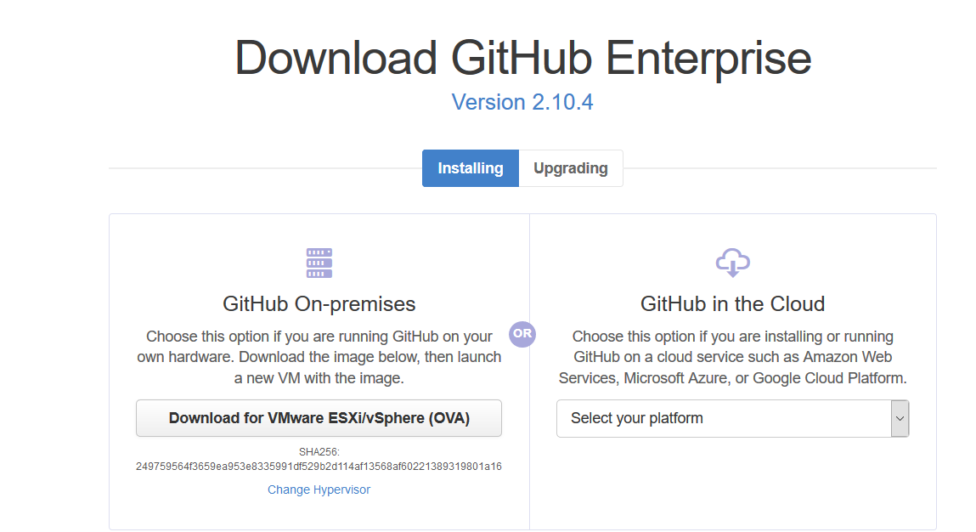
5. What is fork project in github.
6. Ans – here you can search any project in github and if you form it then it will be cloned to your hithub account…this basically means downloading to you github account

BitBucket Installation

BitBucket Installation strategy overview

1. Download installer from bitbucket site
2. Install bitbucket

**Details**

**Prerequisite** - Install the git(for centOS only as it’s already present in ubantu package) before installing the bitbucket (Latest version can be found at <https://www.kernel.org/pub/software/scm/git/>)

1. Download bitbucket installer file from location <https://www.atlassian.com/software/bitbucket/download>
2. 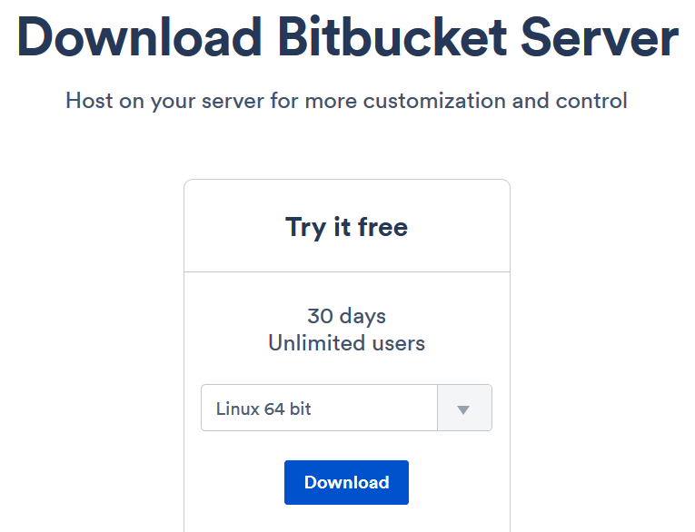
3. Give the installer the full access and run it as below
4. 
5. Follow the prompts and install it.
6. Bitbucket is installed at /opt/atlassian/bitbucket/5.2.2
7. Bitbucket data location /var/atlassian/application-data/bitbucket
8. **Additional information** - Bitbucket also requires ports 7992 and 7993 are available to run an embedded Elasticsearch instance that provides search functionality to Bitbucket.HTTP Port Number [7990]
9. **Once installed, launch the URL in explorer (**[**http://192.168.169.6:7990/**](http://192.168.169.6:7990/)**)**

GIT Client

**Summary** – Git client is installed at user end which is used to pull or push the code in these GIT servers (GITLAB, GITHUB and BitBucket)

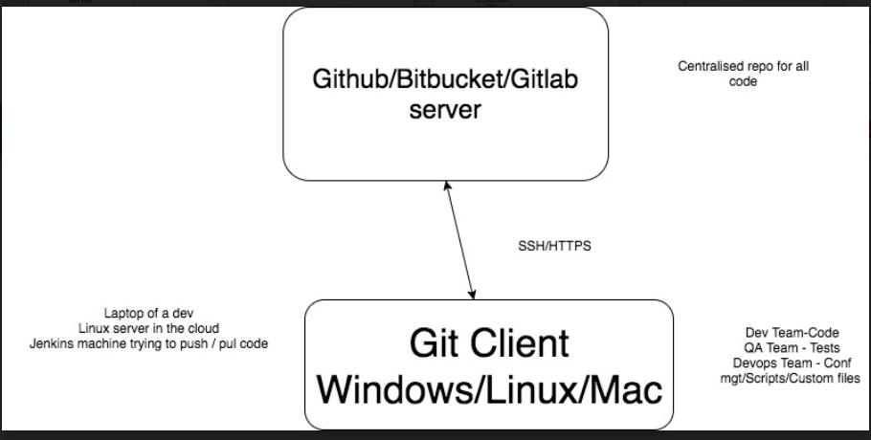

**GIT cloning process**

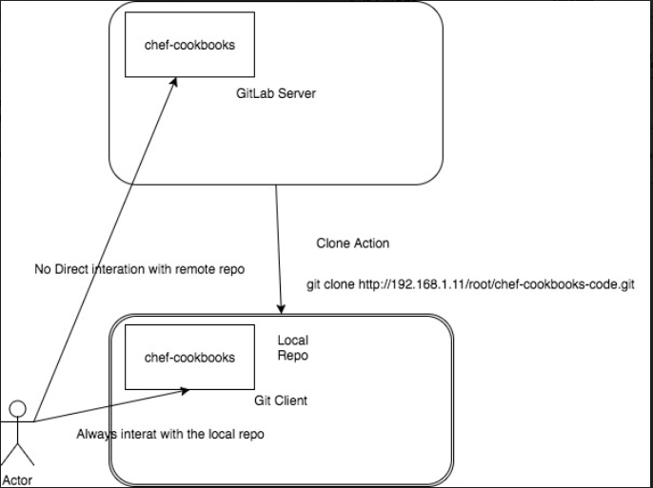

**Git Client Request lifecycle**

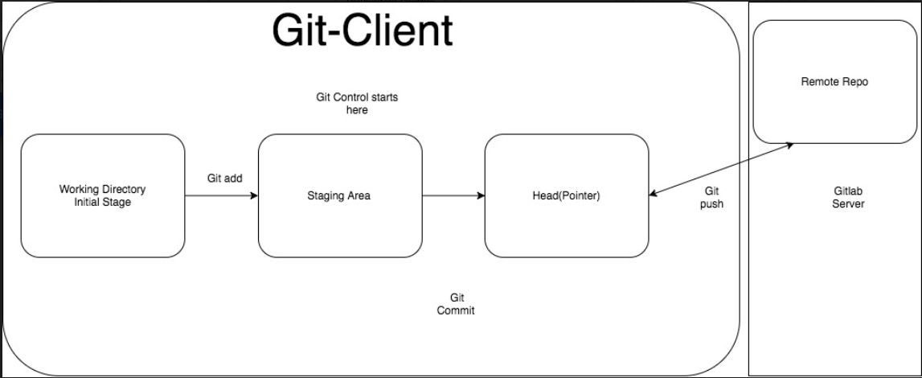

These are the first and basic steps for any git client machine

**For http method cloning**, go to client and run below command( this will clone the project from server to client)

1. git clone <http://192.168.169.5/root/devops-academy-project.git> (***clone command is only for downloading the repository/projects to client, it not for downloading branches***)

2. check status with git status command

3. also run the remote command like git remote –v

4. 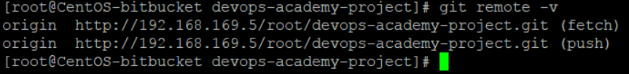

5. Create some file locally in the git clone project and add them to staging area with add command as below

6. git add file_name

7. to roll back the above staging command use the below command (optional …just for knowledge)

8. *use "git rm --cached <file>..." to unstage*

9. Now use the below command to commit them to the header part (check the above diagram to have clarity on this)

10. git commit -m "Pushing first time from client"

11. **Note- For centos and windows machine**, before running the above commit command…first run the below command (git config --global user.email “[invincible.amits@gmail.com](mailto:invincible.amits@gmail.com)” and git config --global user.name "amitsmca")

12. final commad used to push the code on gitserver repository *git push -u origin master*

**Now to Do the same above stuff through SSH method (the ssh advantage is this because it is faster than http and does not require username password for every command)**

1. Run the below command on git client server
2. ssh-keygen -t rsa
3. go to cd /root/.ssh/
4. 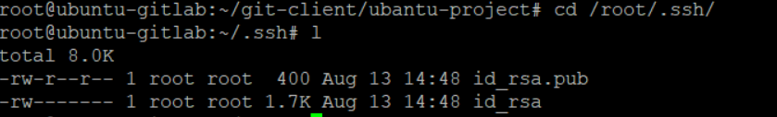
5. Copy the .pub file content and paste on the gitlab server side (in setting🡪 keys)
6. 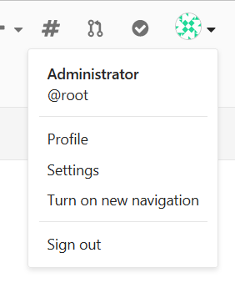
7. 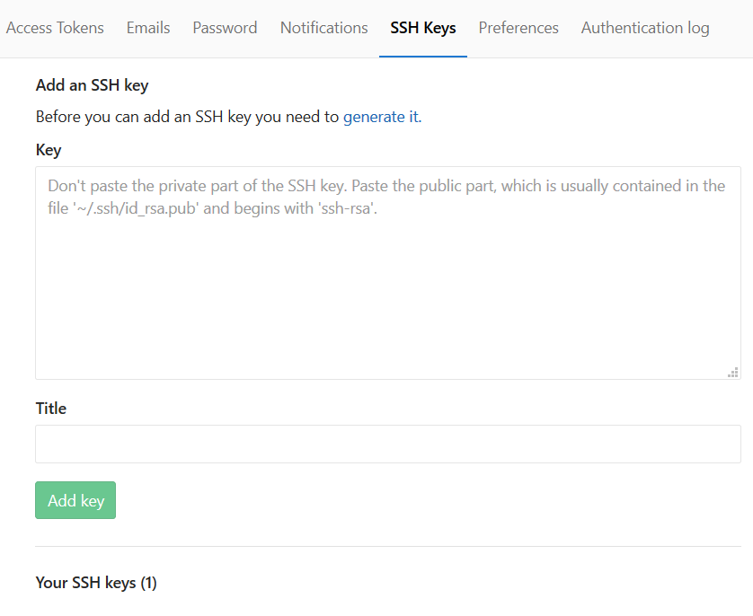
8. Now save the key here and go back to client and do the git client normal stuff using ssh URL now (instead of HTTP)
9. 

GIT Commands

1. If git client is pointing to remote github URL, then below command can be used to make it point to new gitlab url (this is usefull when we migrate from hub to lab and want client to point to this new lab url)
2. Git remote -v (tells that where the client is pointing)
3. *root@ubuntu-gitlab:~/git-client/github-project1# git remote -v*
4. *origin https://github.com/amit-gitgub/github-project1.git (fetch)*
5. *origin https://github.com/amit-gitgub/github-project1.git (push)*
6. use **git remote set-url origin lab/hub url like below**
7. *root@ubuntu-gitlab:~/git-client/github-project1# git remote set-url origin git@192.168.169.5:root/ubantu-project.git*
8. *root@ubuntu-gitlab:~/git-client/github-project1# git remote -v*
9. *origin git@192.168.169.5:root/ubantu-project.git (fetch)*
10. *origin git@192.168.169.5:root/ubantu-project.git (push)*

* **To check out only one of specified files or all files , do the following**

1. Make sure that client is pointing to the correct URL (see above commands)
2. Go to the directory or repository and give command **git pull(this command also fetch the newly created branch at server to client )**
3. This pull command will update all the content inside that directory.
4. Note – As you move in different directory, you get the different branches ( this can be checked using git branch)

* To switch between branches use **git checkout branch_name** ( always remember on which URL you are pushing and pulling by using **git remote –v**
* **How to create a new branch from client(backend)**

1. **CD in to the project**
2. git checkout -b testbranchfromCLIENT
3. Now tell the git server about this new branch on the client side with below command
4. Git add .
5. Git commit – m “New branch”
6. Git push –u origin testbranchfromCLIENT
7. Now go to the server and check if the new branch is created under the project or not.

* **How to get server side newly created branches, to the client side.**

1. Go to project and do git pull
2. Then git checkout branch-name

* **Merging from one branch to other (suppose we want to merge code from dev branch to master branch)**

1. Go to project and check the status of the branch with git status
2. Check out the master branch like git checkout master
3. Now run git merge dev
4. Now git push (or git push –u origin master )(as we are already in the master branch)

* **Git log command is used for the activity happened inside the git like all commits, check out etc some command are given below(Imp – Release notes are created from this)**

1. Git log (it will list down all the activity)
2. Git log –author amit
3. Git log –oneliner
4. Git log –before 2.days.ago
5. Git log –after=”2014-07-01” –before “2014-07-31” --oneline > /home/amit/ release_notes_july_2017.txt

* **Git Merge and rebase**

**Git Merge** - In merge we simply merge the two branches in the merge commit.

Advantage – Going to back to the previous state is possible in merge**.**

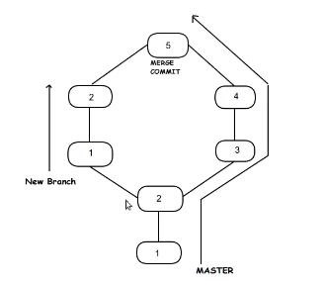

**Git Rebase** – Its means changing the base. Initially when the branch was cut, base was 2. But in rebase, it gets changes to 4 and then the new branch changes merges.

Drawback – It rewrite the commit history.So going bach to earlier state is not possible

Command –git checkout new_branch

Git rebase master

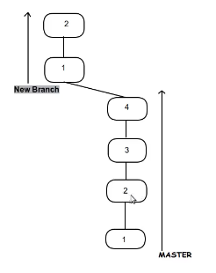

**Git HEAD -** It is always the reference to the latest commit.

It can be used to check the difference between 2 commits.

* **Difference Between git pull and git fetch**

1. **Git pull = git fetch + git merge**
2. **Git fetch :- it takes the commit from the remote repo and keep them on the local repo without merging them. While pull command merge them as well.**
3. **Do a git fetch in dev branch then do git diff origin/master (note in this master branch file was updated by other developer)**
4. **Now do the git merge origin/master (now this will sync the changes in your dev branch from master branch)**

* **Merge Conflict**

1. **Merge conflict happen when two developers try to change the same line of the sa me file**
2. **Scenario – change some file at remote and commit, now change the same line for the same file at local and do the following**
3. **Do git add. && git commit –m “local comit” && git pull . this will show the conflict like below.**
4. 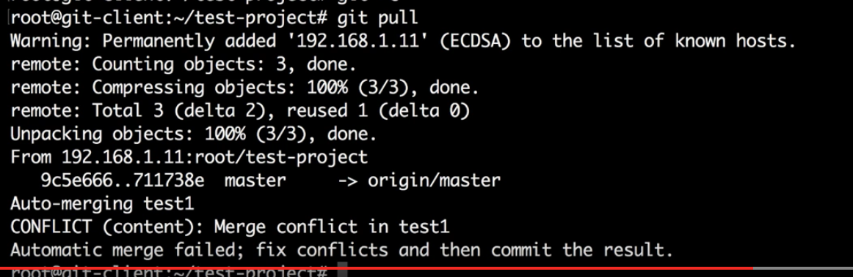
5. **Now open that file in vi and you will see something like below**
6. 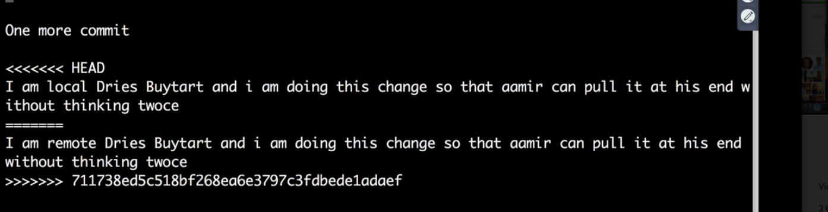
7. **Now remove the stuff and keep what ever you want from <<< head and >>>> and push the changes.**

* **Git rm command**

1. **This rm command is used to delete some file at remote server side. Ex. Log file or any other file you don’t want.**
2. 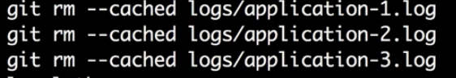
3. **After above command say git commit –m “removing logs” and then git push**

**Stash Command – this is like temporary area where you can keep you changes for some time**

1. **Modify some file and if you don’t want to remove the changes for some time then type git stash.**
2. **Now check your file, your changes would not be there.**
3. **Now to get back the changes git stash apply**

**Init command – this git init command make some normal directory as git directory**

**Git config command – this lets you set the user related things like**



**Gitlab email integration**

1. **Email service provided like amazon SES provide the smtp setting which we have to keep in** /etc/gitlab/gitlab.rb file

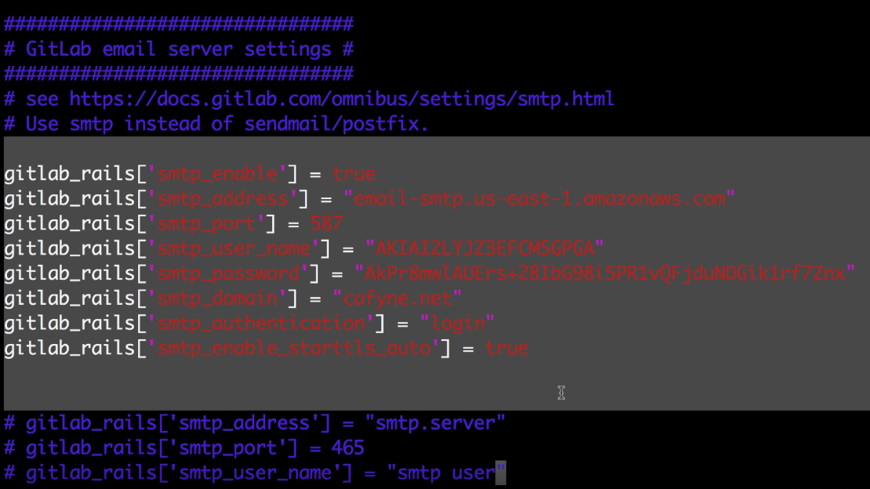

1. **One above is added do the gitlab-ctl reconfigure**

**Gitlab and jira integration(follow below)**

[**https://docs.gitlab.com/ee/user/project/integrations/jira.html**](https://docs.gitlab.com/ee/user/project/integrations/jira.html)

**this integration helps in marking the issues in jira fixed automatically**

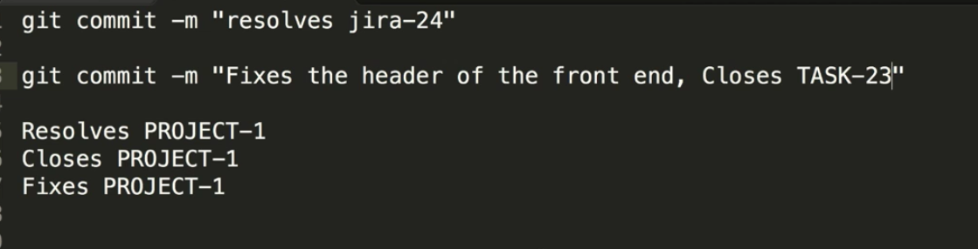

**Branching strategy**

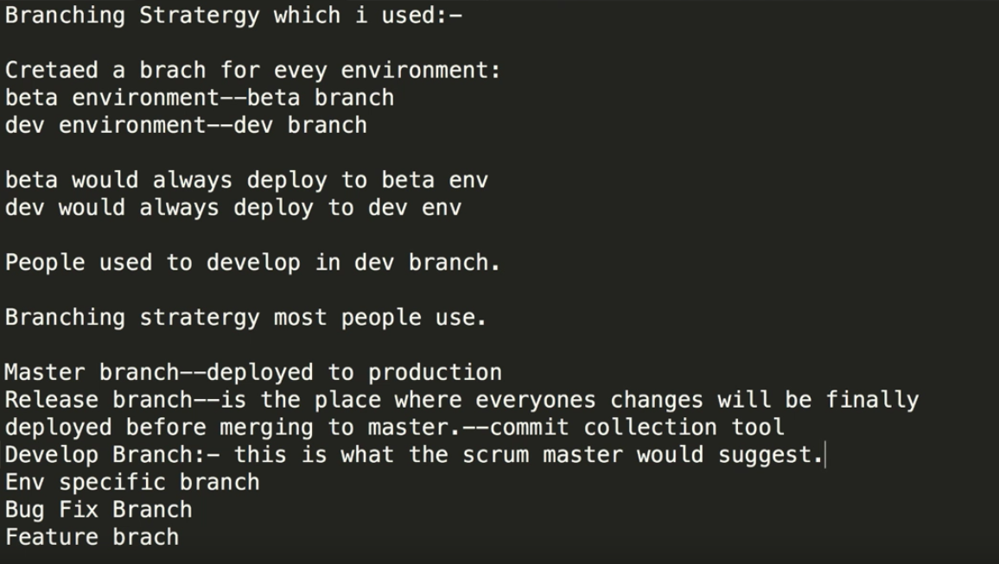

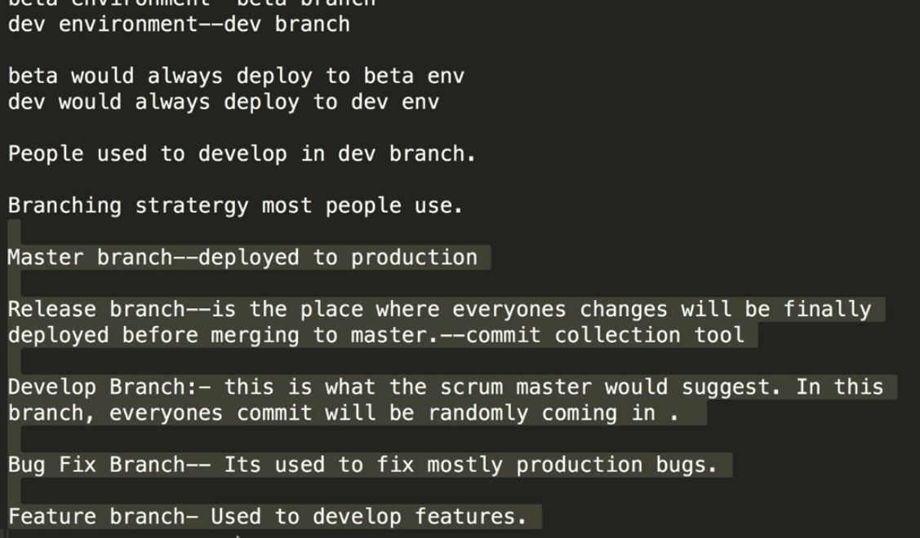

***important command for git in ubantu machine***

*Below command remove the git from the ubantu machine*

*apt-get remove git -y*

*Below command installthe git in the ubantu machine*

*apt-get install git -y*

Important links for GIT

<https://git-scm.com/downloads>

*set incremental pull in jinkins using git*

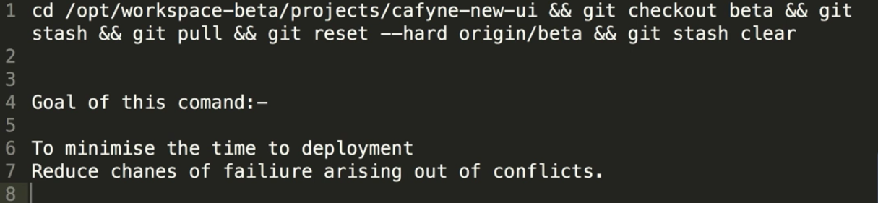

+++++++++++++++++++++++++++++++++++++++++++++++++++++++++++++++++++++++++++++

End

+++++++++++++++++++++++++++++++++++++++++++++++++++++++++++++++++++++++++++++

Ci-Cd

## Jenkins

Jenkins is the most popular **ci-cd (continues integration and continues deployment**) tool (written in java) and its open source.

### Jenkins installation steps on Ubuntu

1. Download the Jenkins key on the newly build Ubuntu server.
2. ***Wget*** [***https://pkg.jenkins.io/debian/jenkins-ci.org.key***](https://pkg.jenkins.io/debian/jenkins-ci.org.key)
3. This will download a Jenkins key to the apt cache which will be required for security purpose.
4. ***Apt-key add jenkins-ci.org.key (this will import the key certificate to jenkins server)***
5. Now list all the sources from where Jenkins should be downloaded.
6. ***Vim /etc/apt/sources.list.d/jenkins.list (and put the below text in this file)***
7. Deb https:pkg.jenkins.io/debian-stable binary/ (and save this file)
8. Now update the apt cache with command ***“apt-get update -y”***
9. **Now install the Jenkins** as below
10. ***Apt-get install Jenkins –y***
11. Once installed, check the ip with ifconfig and listening port with “netstat –nautpl | grep LISTEN”
12. For future upgrade do “apt-get upgrade Jenkins -y”
13. Now go to the server_ip:port and launch Jenkins
14. Now it will ask for the one time password from below location /var/lib/jenkins/secrets/initialAdminPassword
15. 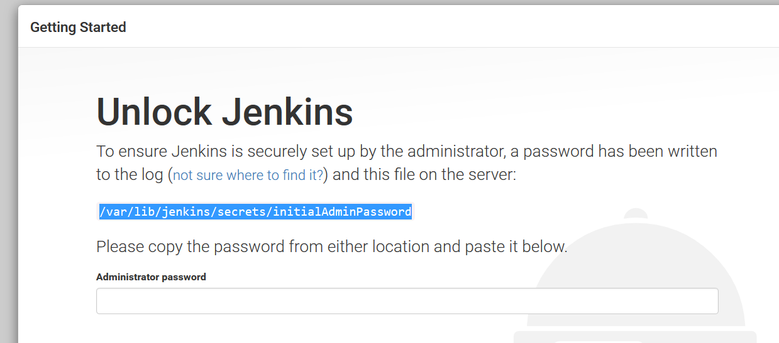
16. Copy from above location and paste in the text bar and continue.
17. Now install the suggested plugin
18. 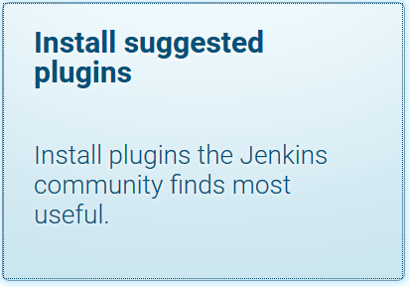
19. Once the plugins are installed , create admin user (root/redhat)
20. 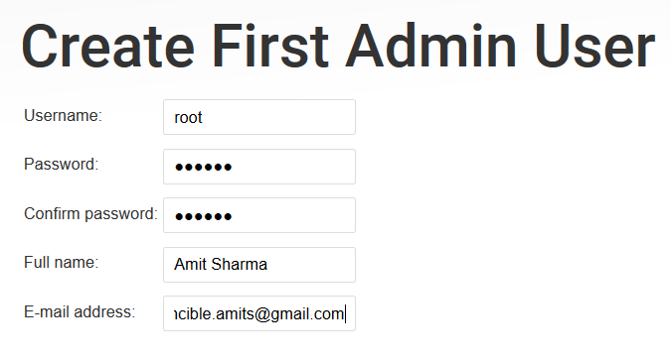
21. Save and finish.
22. systemctl status Jenkins ( to check the Jenkins status manually on server)

### Jenkins best practice after setup

1. Got to Manage Jenkins🡪 configure global security and tick the checkbox to allow users to signup.
2. 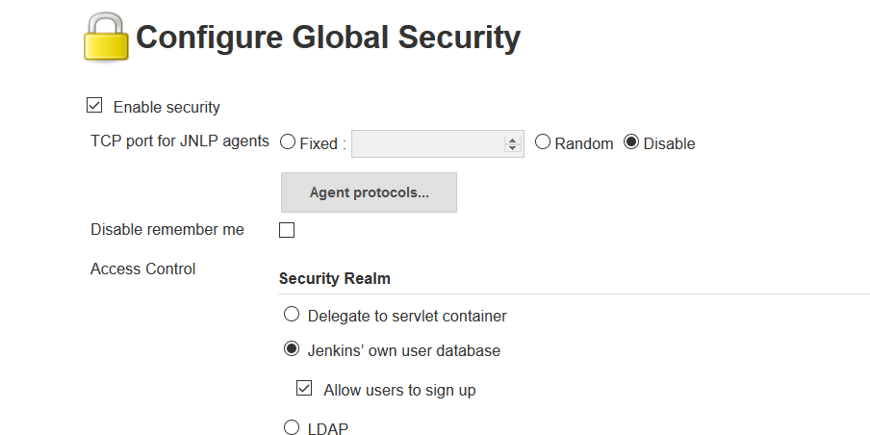
3. Now to define the role and access level, go to configure global security🡪 matrix based security 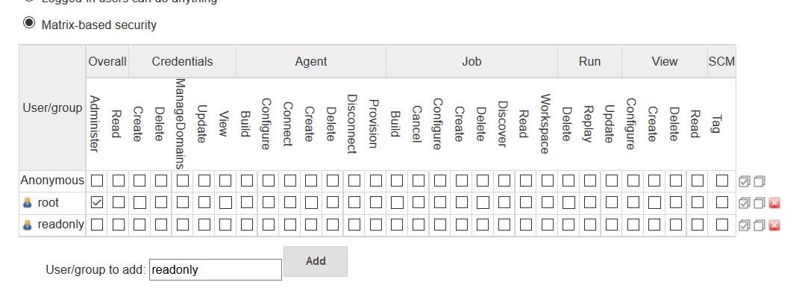

#### Below is the diagram that shows the relation between gitlab repo, Jenkins and nginx(web application server)

Here Code Repo – Gitlab server where our projects resides

Ansible – ansible small module is setup inside the Jenkins server to do the configuration management (also to do the code checkout from code repo to Jenkins server)

Jenkins – This is the Ci-CD tool which will do the project build.

Target machine – this is nginx web application server where the code will be deployed from Jenkins server.

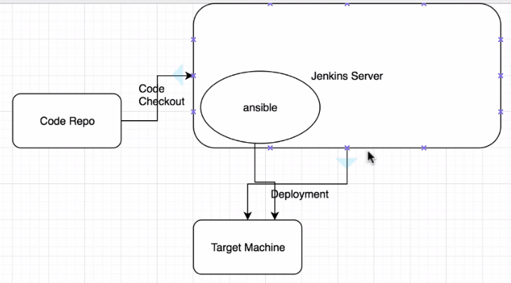

### Install nginx on new Ubuntu machine

1. Create a Ubuntu VM from scratch and update the server as usual (refer gitlab document on what update command to perform as best practice like apt-get update –y then apt-get dist-upgrade –y and then apt-get autoremove -y)
2. Run apt-get install nginx
3. Now check status sudo /etc/init.d/nginx status
4. The above can be used to start and stop nginx

### How to install ansible on Jenkins server

1. First install the ansible dependency with below command(for centos u might need to install daily as it might go away with the session but for ubantu its automatic and always there)
2. apt-get install software-properties-common –y
3. now add the ansible repository
4. apt-add-repository ppa:ansible/ansible
5. now update the apt cache with apt-get update –y
6. now install with apt-get install ansible –y
7. once installation done, configure ansbile to make it work on Jenkins machine
8. vim /etc/ansible/ansible.cfg
9. Now disable the host key checking as below
10. 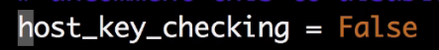
11. Now tell ansible which servers it needs to connect to like localhost Jenkins server, nginx server etc.
12. Vim /etc/ansible/hosts (clear all the previous defaults contents)
13. Put the below text in above file
14. [local]

127.0.0.1 ansible_ssh_user=root ansible_ssh_pass=redhat

1. First check the connectivity with the local host like
2. ansible local -m ping
3. 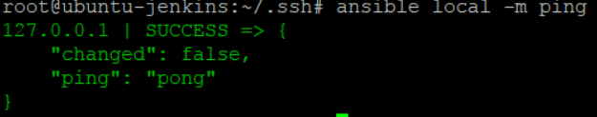
4. Now give all the nginx server as below(these are userid and password of the nginx server)
5. 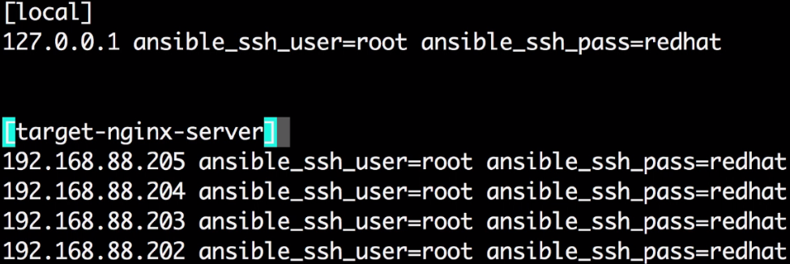
6. Make sure that the jenkins server ssh key is added on gitlab server from Jenkins server.
7. If build fails saying unable to connect, then try to clone the project from Jenkins server using normal git clone command. Also pay attention to the git remote –v output to check the target url.
8. Set *StrictHostKeyChecking no* in the cat /etc/ssh/ssh_config by uncommenting these two lines
9. 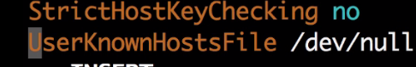
10. Now set the following to checkout the code on jenkin server from gitlab server
11. Go to project -> config 🡪 build 🡪 execute shell
12. 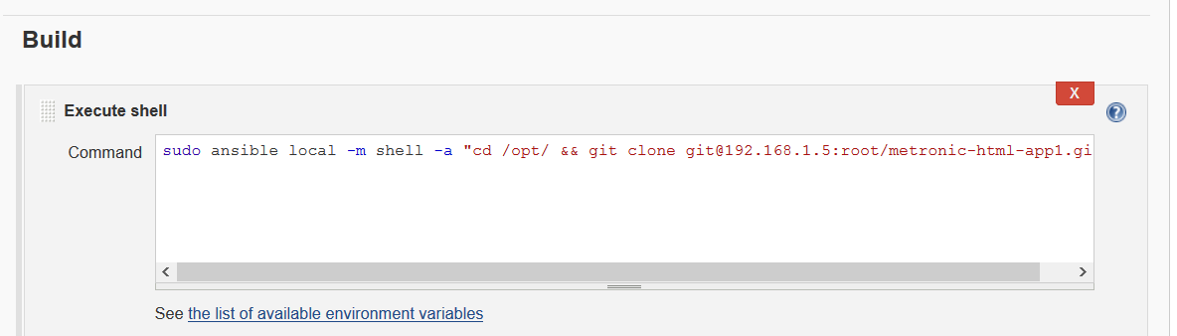
13. And hit the build and check the console.
14. As best practice on the Jenkins server under /opt directory create a workspace and other directories like below
15. 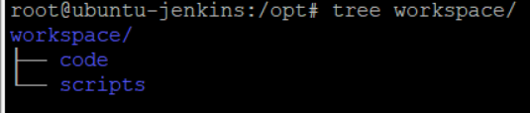

#### Now Deploy the app on the target machines(here njinx server)

1. Go to the target machines app server web directory /var/www/html
2. Now go to the project [copy-to-target-machines](http://192.168.1.11:8080/job/copy-to-target-machines/) configuration
3. Build 🡪 Execute shell and set the following
4. sudo ansible target-machines -m shell -a "rm -rfv /var/www/html/*"
5. sudo ansible target-machines -m copy -a "src=/opt/workspace/code/metronic-html-app1/ dest=/var/www/html"
6. 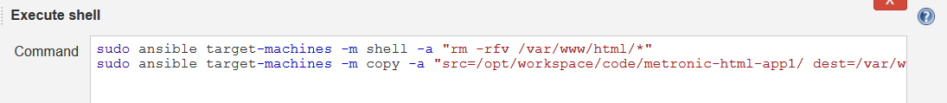
7. Now build it

#### Building the project pipeline

1. Go to Manage Jenkins🡪Manage plugins🡪 advance and search for build pipeline plugins
2. 
3. Click checkbox and download and install after restart.
4. 
5. Once downloaded , check the box restart Jenkins and Jenkins will restart
6. Now build the pipeline after clicking on + button
7. 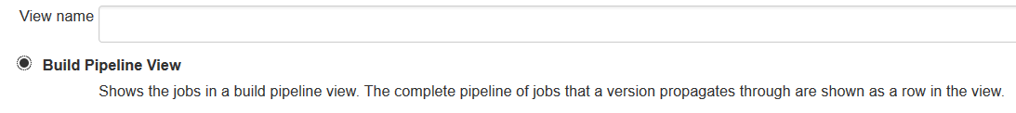
8. Now go to the first build (check-out-code) and click configure.
9. Now go to end to make a upstream-downstream build connectivity
10. 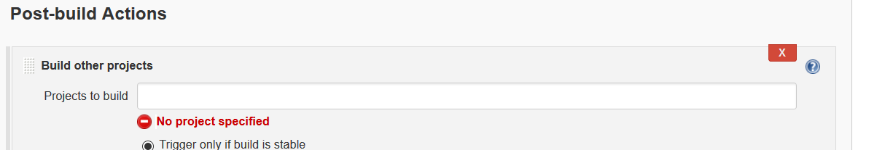
11. Now give next build name and save
12. 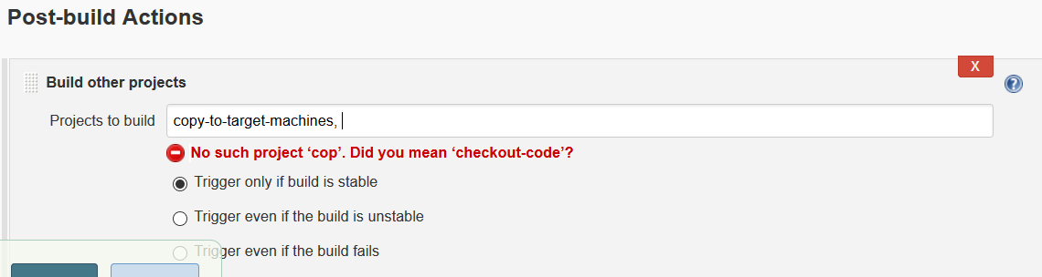
13. Now this will list as downstream projects
14. 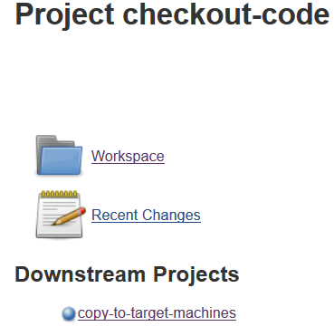
15. Do the same with remain build to create a build chain.
16. Now run the build pipeline
17. 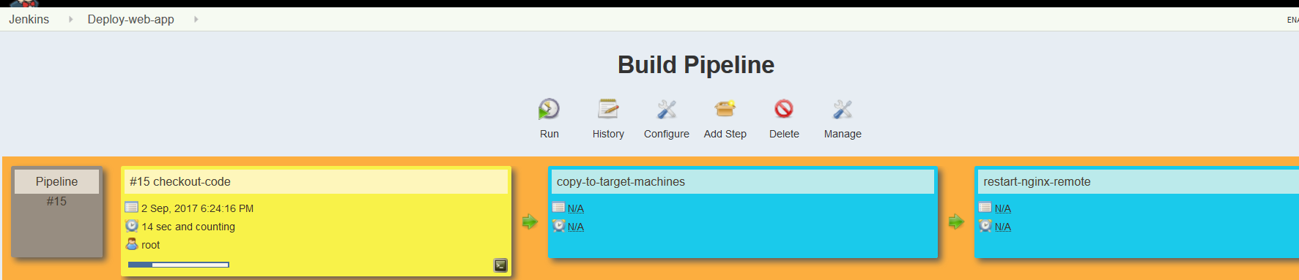

#### Install Tomcat on target servers

1. The same njinx machines can be used to install tomcat (just stop the tomcat service)
2. First install the latest jdk on machine (apt-get install default-jdk –y)
3. Now as best practice before installing tomcat, create tomcat group by groupadd tomcat
4. Now create a tomcat user( with false shell means it cant login and opt/tomcat home directory)
5. useradd -s /bin/false -g tomcat -d /opt/tomcat tomcat
6. install tomcat in /opt/tomcat
7. install it with the help of binary file available on tomcat site
8. 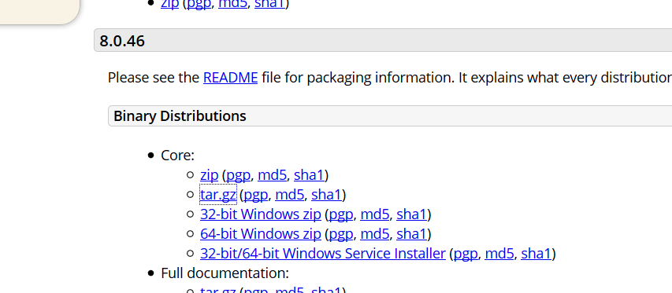
9. Copy the link for this tar.gz file and do below.
10. Wget <http://www-eu.apache.org/dist/tomcat/tomcat-8/v8.0.46/bin/apache-tomcat-8.0.46.tar.gz>
11. Unzip it tar -xvzf apache-tomcat-8.0.46.tar.gz -C /opt/tomcat/ --strip-components=1
12. The above command will force it to unzip it in single /opt/tomcat dir without creating subfolders.
13. Change few permissions like below.
14. chmod -R g+r conf/
15. chmod g+x conf/
16. chown -R tomcat webapps/ work/ temp/ logs/
17. Now copy the tomcat startup script from internet (<https://pastebin.com/x5D9im9a>)
18. Paste this script in file vim /etc/systemd/system/tomcat.service
19. 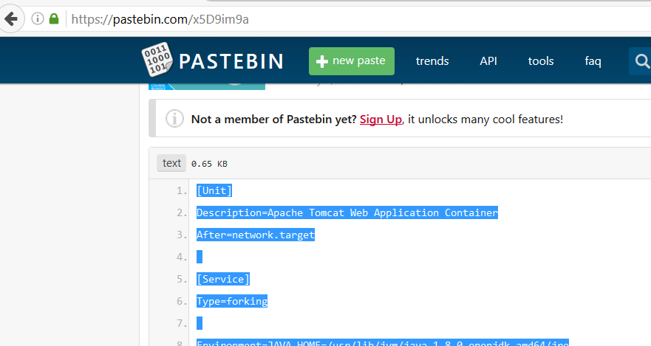
20. Now reload the system deamon with command systemctl daemon-reload
21. Now start tomcat and check the status systemctl start tomcat.
22. Now take the ip check on browser on port 8080.
23. If does not work then try following
24. systemctl enable tomcat
25. check log /opt/tomcat/logs/ catalina.out
26. also group change in tomcat directory required. Do the following
27. 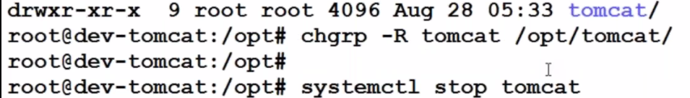

#### Creating project pipeline for multiple environment

1. Create free style new items in Jenkins like below
2. 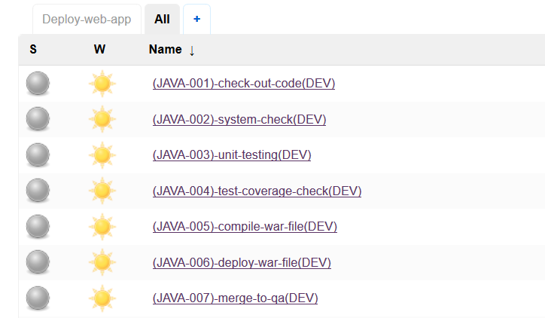
3. Now connect these builds to one another so that they can kick-off one another.
4. Click on the first build and configure like below
5. 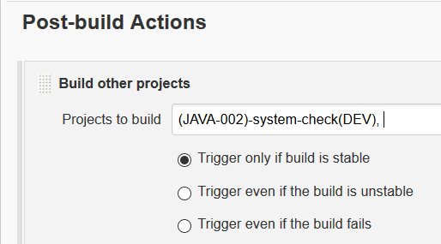
6. Above, build 1 will kick-off 2 and 2 will 3 and so on.
7. Do the same build for other build as well
8. Now Create a pipeline for these interconnected build
9. 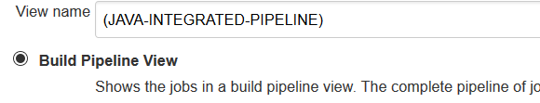
10. Now go to first code-check-out build and give the git repo http URL
11. 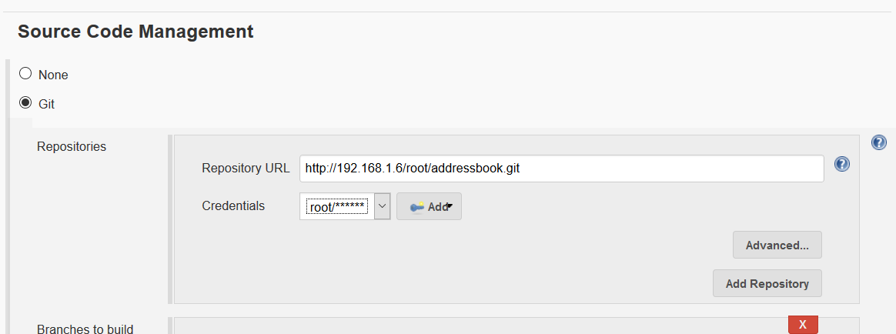
12. Now build this project to check if the code checkout is successful or not.
13. Now move to next build which is code syntax check. For this pmd plugin will be required.
14. Go to manage Jenkins🡪 manage plugins🡪 Available🡪 PMD plugin
15. Now install it without restart.
16. Now go to syntax check project🡪 config and do like below
17. 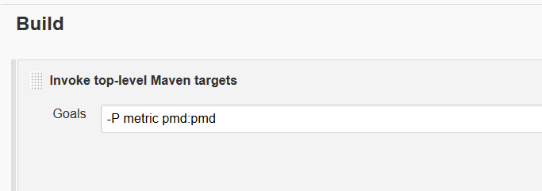
18. Now go to post build action🡪 publish PMD analysis and save it.
19. 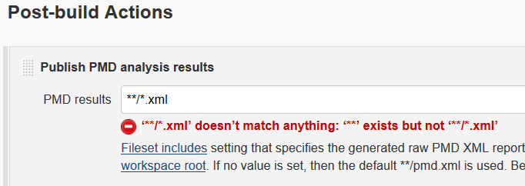
20. Now install the maven binary
21. Go Manage Jenkins🡪 global tool configuration
22. Add java jdk with credentials like below
23. 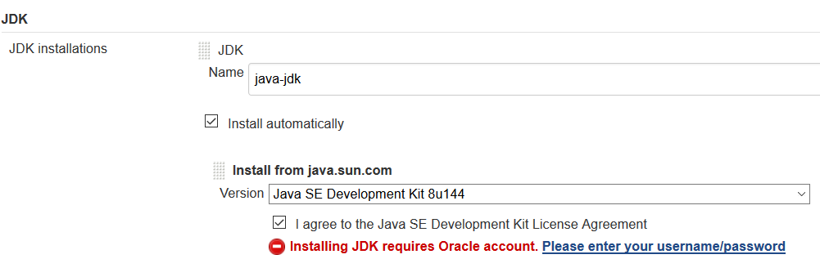
24. Also add maven like below
25. 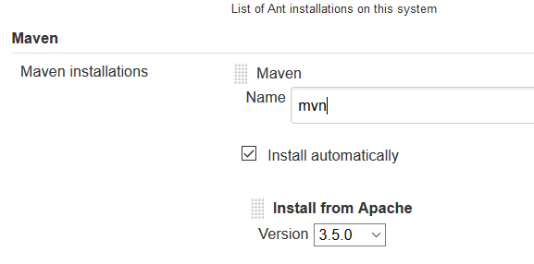
26. Make sure maven is set like below before building the project
27. 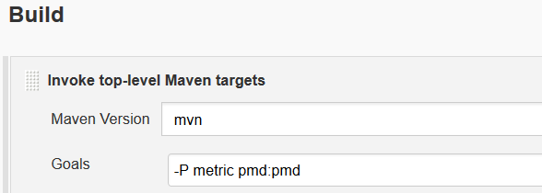
28. Now build the project.
29. In case of any failure make sure the git http url is specified in project config.
30. Now proceed for the Junit testing project
31. Go to Unit-testing🡪 config and give git url
32. 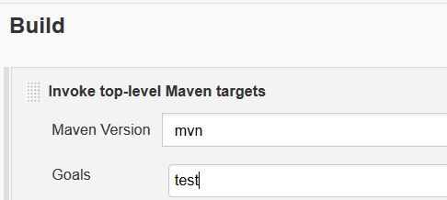
33. Here test plugin is also required so go to manage Jenkins🡪 manage plugins
34. Search for below plugin and install it
35. 
36. Go to config and
37. 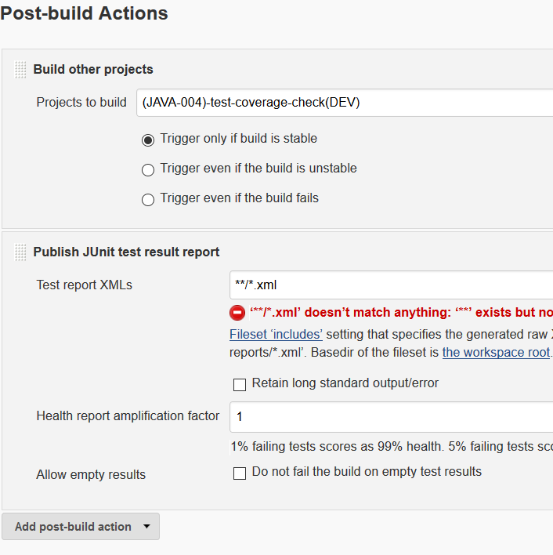
38. Now build the project and check the unit test results.
39. Now move to test coverage check build and go to config and provide the git url with dev branch
40. 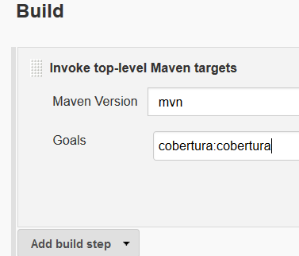
41. Mention cobertura like above.
42. Now install the coberture plugin. Manage Jenkins🡪 Manage plugin🡪Available🡪Cobertura plugin and install.
43. 
44. Also install html publisher plugin
45. 
46. Now configure the test coverage project as below (this html report gives the details how much code is accessible by the cobertura)
47. 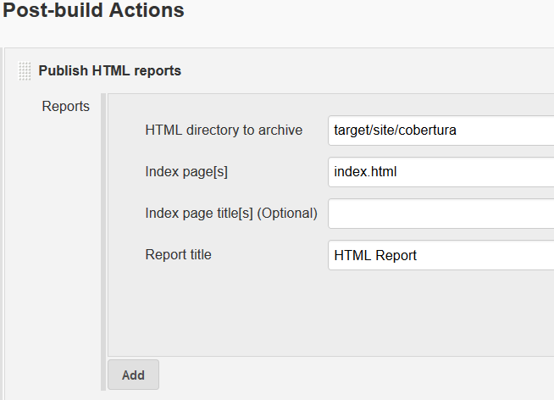
48. Build other project should always come last.
49. Now restart Jenkins as best practice.
50. Now move to compile war file build and do the basic configuration of git and maven as above and specify as above
51. 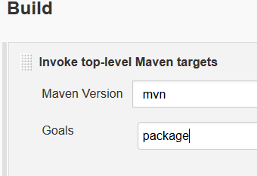
52. 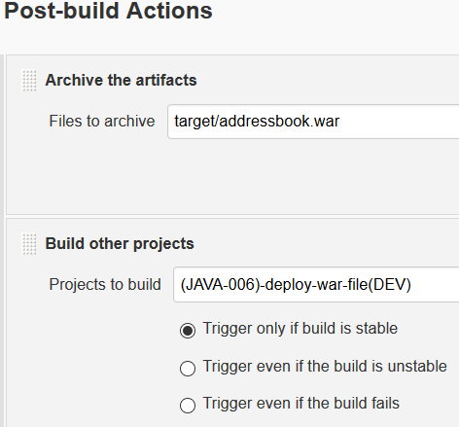
53. This Archive the artefact will show the war file on the project after the build as below.
54. 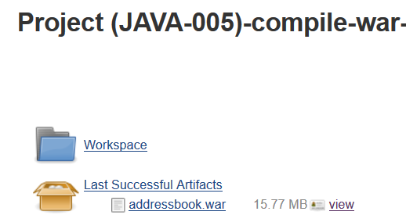
55. Build this project to check if it works (after building it will show the above war file)
56. Now deploy the war project build. Set up the ansible script like below in config
57. *sudo ansible local -m shell -a "cp /var/lib/jenkins/workspace/\(JAVA-005\)-compile-war-file\(DEV\)/target/addressbook.war /opt/"*
58. *sudo ansible target-machines -a "rm -rfv /opt/tomcat/webapps/addressbook.war"*
59. *sudo ansible target-machines -m copy -a "src=/opt/addressbook.war dest=/opt/tomcat/webapps/"*
60. *sudo ansible target-machines -m shell -a "systemctl restart tomcat.service"*
61. 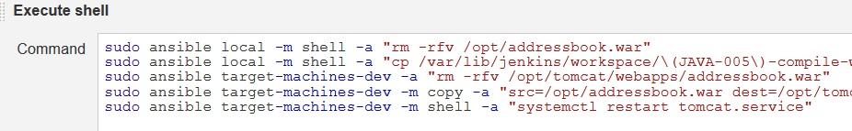
62. Go to the Jenkins and tomcat server and check if above paths are correct or not.
63. Now make the config change in the last build of dev branch which is merge-to-qa branch.
64. *sudo ansible local -m shell -a "rm -rfv /opt/workspace/temp_area/code_checkouts/*"*
65. *sudo ansible local -m shell -a "cd /opt/workspace/temp_area/code_checkouts && git clone git@192.168.1.6:root/addressbook.git"*
66. *sudo ansible local -m shell -a "cd /opt/workspace/temp_area/code_checkouts/addressbook && git checkout dev"*
67. *sudo ansible local -m shell -a "cd /opt/workspace/temp_area/code_checkouts/addressbook && git pull"*
68. *sudo ansible local -m shell -a "cd /opt/workspace/temp_area/code_checkouts/addressbook && git checkout qa"*
69. *sudo ansible local -m shell -a "cd /opt/workspace/temp_area/code_checkouts/addressbook && git pull"*
70. *sudo ansible local -m shell -a "cd /opt/workspace/temp_area/code_checkouts/addressbook && git merge dev"*
71. *sudo ansible local -m shell -a "cd /opt/workspace/temp_area/code_checkouts/addressbook && git push"*
72. The above commands will checkout and merge the dev changes in qa branch.
73. 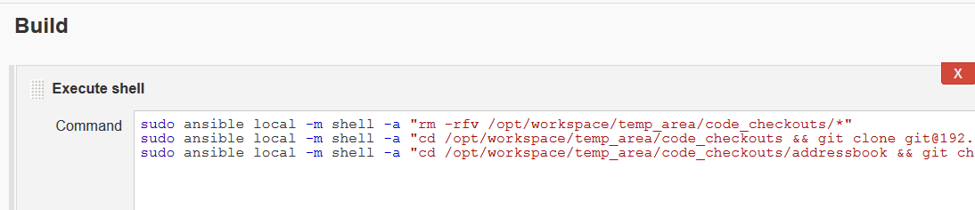
74. Now build this project to make sure it working fine.
75. Continue with the same pipeline for qa as well and merge it to the preprod and follow the same for preprod🡪 prod.
76. Just make sure in the deploy war file build, build config is set as below
77. 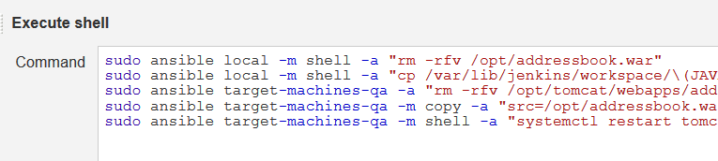
78. For deploy war file **dev build, target machine should be dev and map the same in ansible host file as below.**
79. 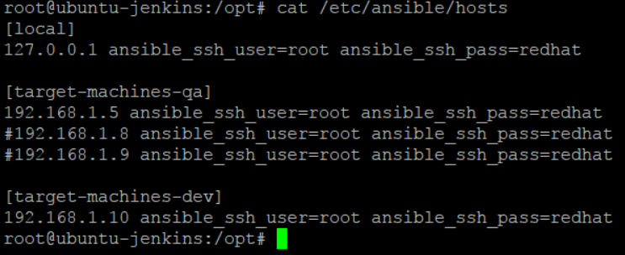
80. 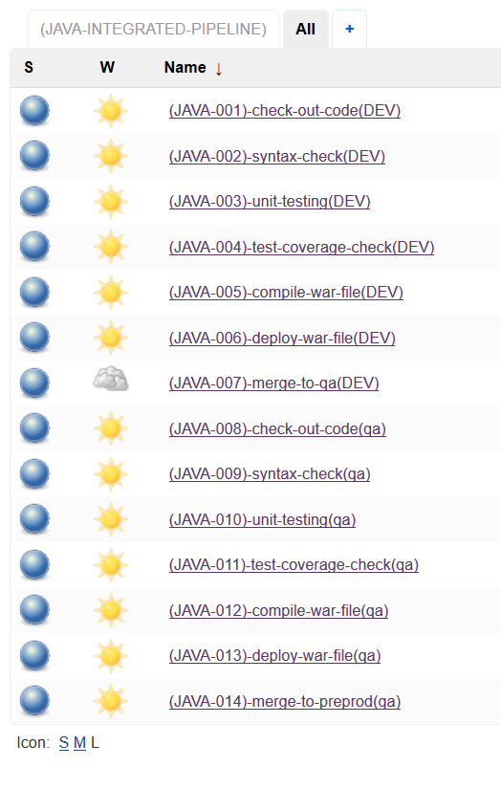
81. While make the new project copy it from the same old dev branch counterpart project and just change the branch and other setting.Follow the same logic as we did for dev branch pipeline(this time just for different branch and different target machines and make sure these target machines are added in ansible host file)

**How to refresh code with changes only rather than going for cloning of full project**

1. **Go to the config of the build and create a shell script like this(rather then do the git clone)**
2. 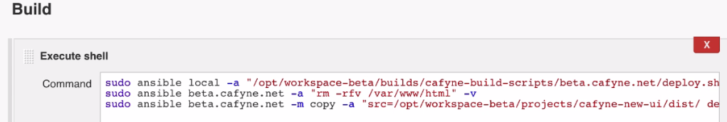
3. **Now go to the above path on Jenkins servers and create a deploy.sh script like below.(also put –v at the end of script above)**
4. 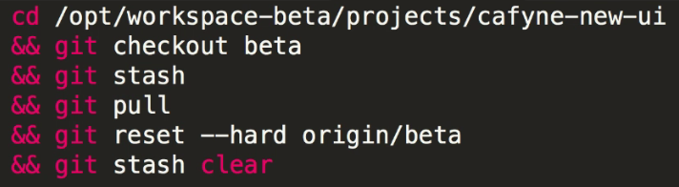
5. **Put the above test after replacing the branch name in deploy.sh script**

Create backup of the war file

1. Create a separate job and place it before last build where we deploy the war to the target servers
2. 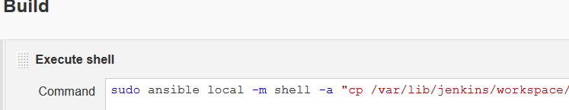
3. Put the below text in this script
4. *sudo ansible local -m shell -a "cp /var/lib/jenkins/workspace/\(JAVA-005\)-compile-war-file\(DEV\)/target/addressbook.war /opt/addressbook-`date +%s`.war"*
5. Now bring this job in pipeline by setting the upstream and downstream projects.

## Email Integration with Jenkins

First install the below plugins in Jenkins

1. Manage Jenkins🡪 Manage plugins and search for email extension plugin and extended email notification plugin and install them (if not installed already)
2. Go to any build project and select editable email notification
3. 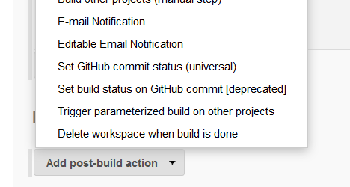
4. 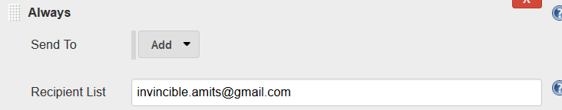
5. Now we need to set the SMTP server details which Jenkins will use to send mail( we are using gmails smtp server here to send mails from Jenkins)
6. Manage Jenkins🡪 configure system
7. 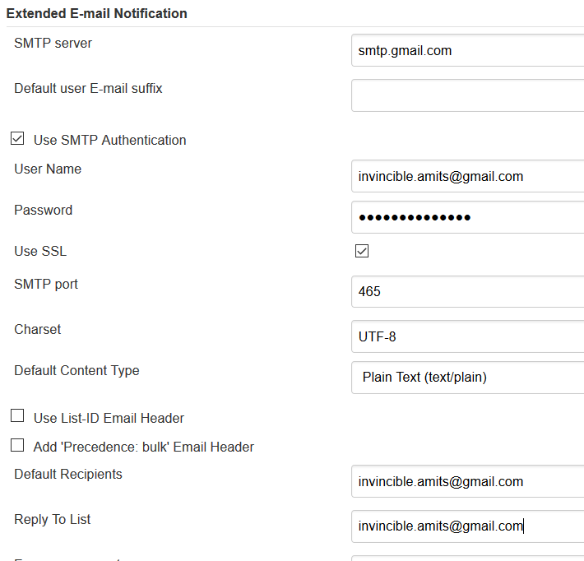
8. Used the below gmail settings
9. 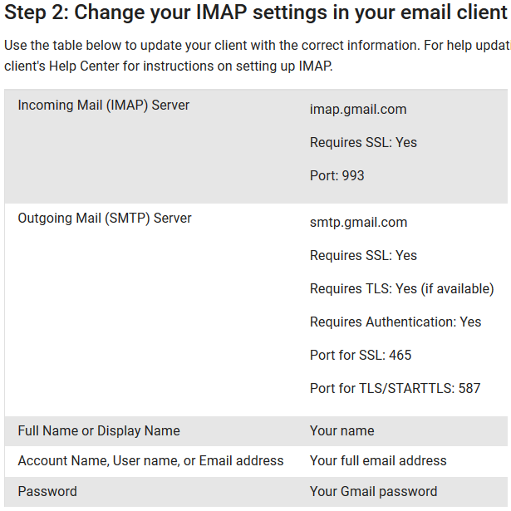

**Difference Between Continuous Integration, Continuous Deployment and Continuous Delivery**

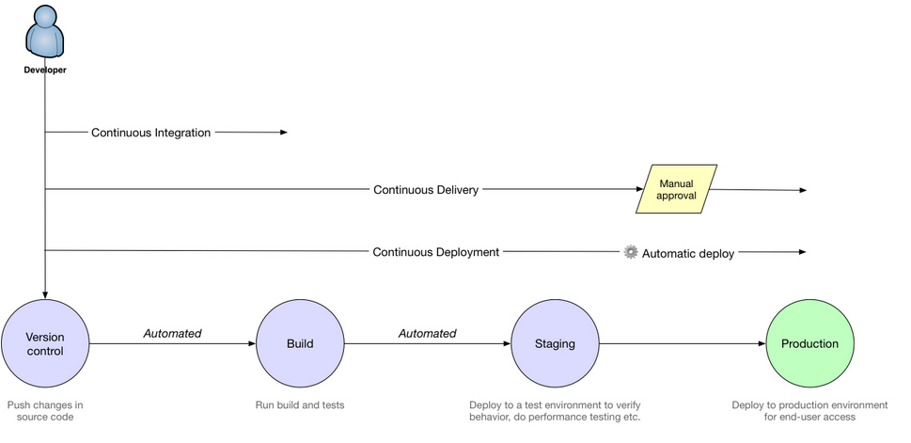

**Polling GIT hub for every code commit and starting Jenkins build automatically**

1. Make sure webhook is configured inside the github project repository. This is Jenkins server URL/github-webhook
2. 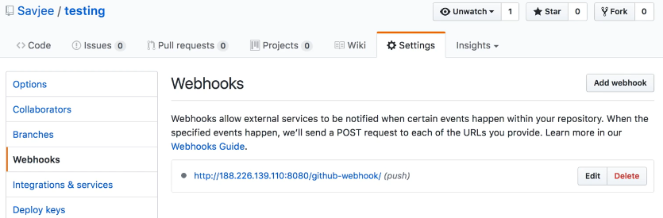
3. This is to tell t Jenkins that there is a change in github repository.
4. At the Jenkins side, install the github integration plugin and configure the job with github ULL details and check the below setting which will poll the web hook URL and trigger the build.
5. 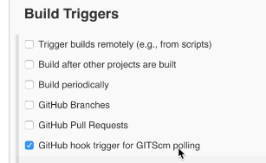

List down the most important plugins of Jenkins – very important

***Important***- In all the build projects, the post build action(build another project) should always be the last task to execute as next build should only be triggered once all other tasks are completed for a project ( if it is not last, then drag it to last position)

***Important*** *- The advantage of using ansible in Jenkins is because you can disable the host key checking in ansible which would help in automating the build process (as no prompt or password will be asked during check/build and deployment process)*

***Important point to learn*** *– host key checking can also be disabled in linux cat /etc/ssh/ssh_config But it is not recommended as it a security compromise*

++++++++++++++++++++++++++++++++++++++++++++++++++++++++++

END

++++++++++++++++++++++++++++++++++++++++++++++++++++++

Chef

# Chef Architecture

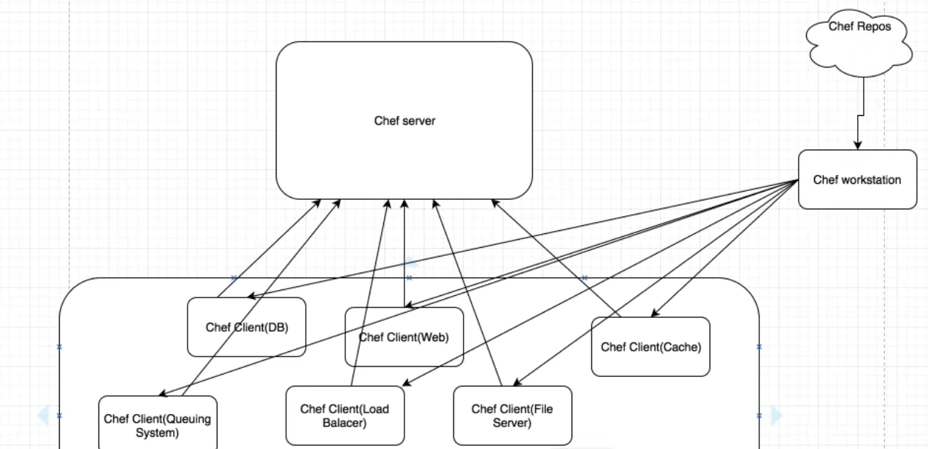

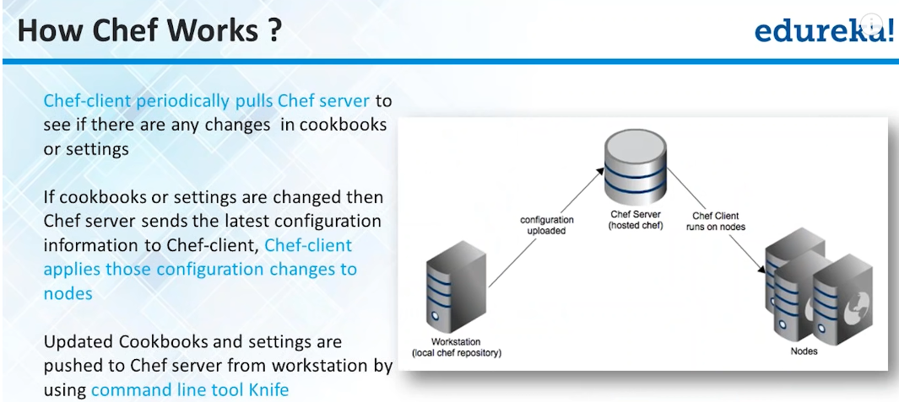

#### Chef Workstation

This is responsible to get the client registered with chef server. So basically workstation does the initial talking with clients. Workstation talks to chef repos (which are hosted on the internet) and get the chef client downloaded on all the machines and do the registration with chef server.

#### Chef advantage over puppet

In puppet, we must do the registration manually on all the clients.

# Chef components

Organization – This represent a separate group like different company or different domain or departments etc. Organisation is to make sure that no organisation infrastructure is visible to other.

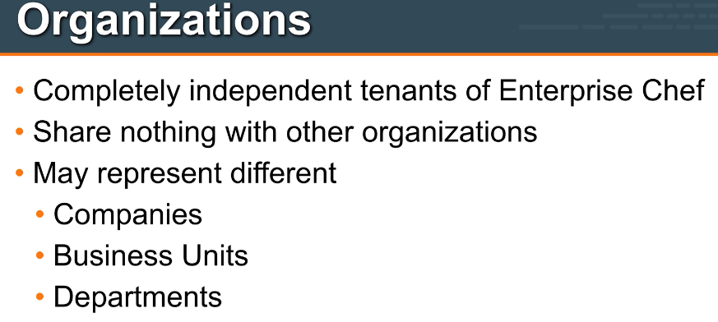

Environment – This is second big entity which describes the different env like dev, prepro, prod. Environment may include data attributes which are required to configure infrastructure.

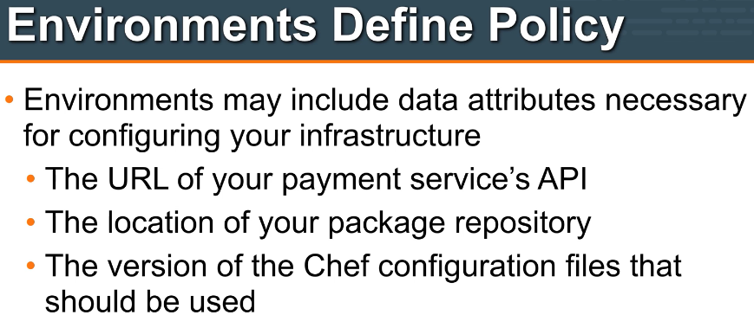

Whenever environments come, think about dev, preprod, prod etc. Environment gives us the ability to use the different versions of the same cookbook across different env like dev, preprod and prod.

Environment is directly created under chef-repo (as it must work on all the cookbooks)

Sample environment looks like below

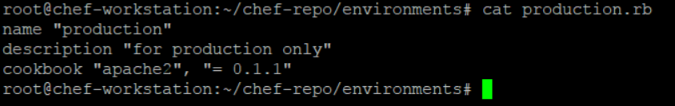

At admin console it looks like below

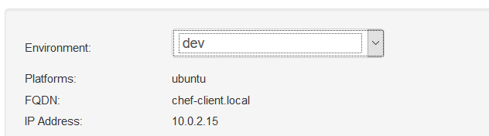

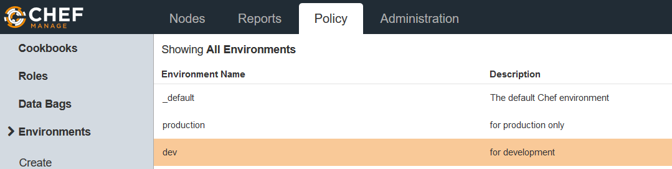

**Important – Environment take the version of a cookbook from its metadata file. Sample below**

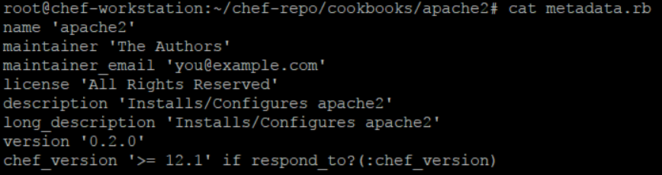

For example, the below apache cookbook version is changed to 0.2.0 and when it is uploaded to server, the environment will consider as one piece of code under 0.2.0 version of this cookbook. If we specify this version inside the environment .rb file then chef will load this particular version for that cookbook.

Check environment commands in the chef commands section.

Roles – Roles defines the type of servers in the infra. Like DB server, cache server, web, application servers etc. Roles may include the chef config files that should be applied. This is called Run List

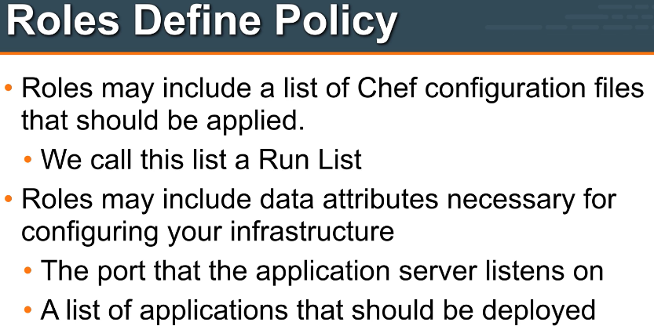

# Important points about Roles

Whenever think about role, think about the different types of nodes like some are web server, some are application server, db servers etc. Roles are not related to some cookbook but for whole environment as they are used by nodes and contains cookbooks. This is the reason roles are directly under chef-repo. Sample role look like below.

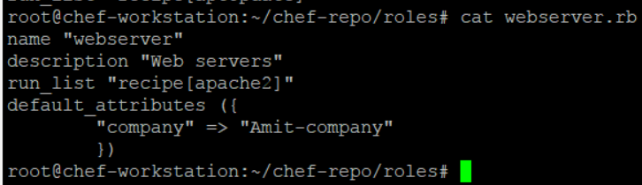

Roles basically contains the cookbooks (one on many) and hence are used in runlist. (rather than pushing separate cookbooks in runlist, we push the roles)

Role runlist at admin console look like this

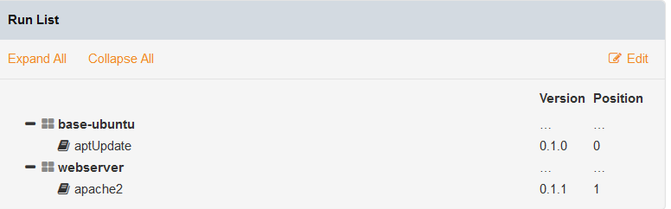

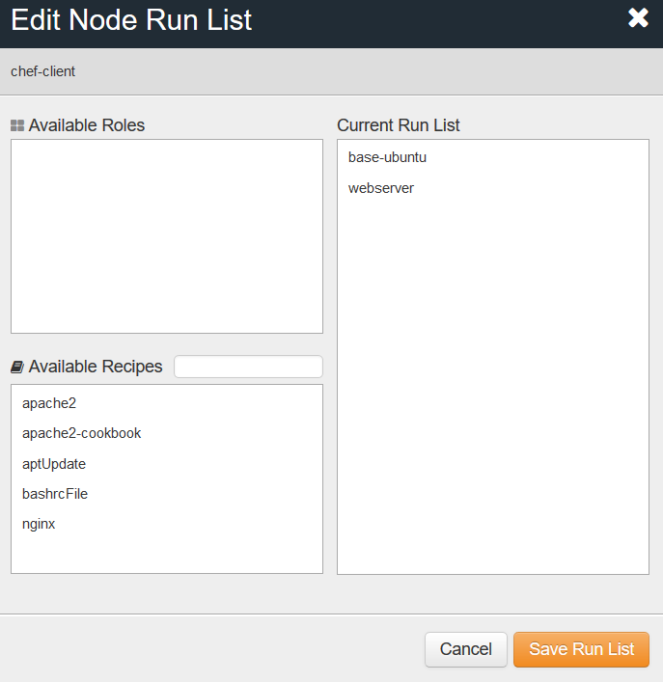

# Understanding Starter Kit, chef-repo, berksfile, metadata.rb and knife command line utility

Once the organisation is created on chef server (personal or hosted), we download a starter kit (chef-starter.zip) and unzip it on the chef-workstation. This create the following **chef-repo** folder and contents.

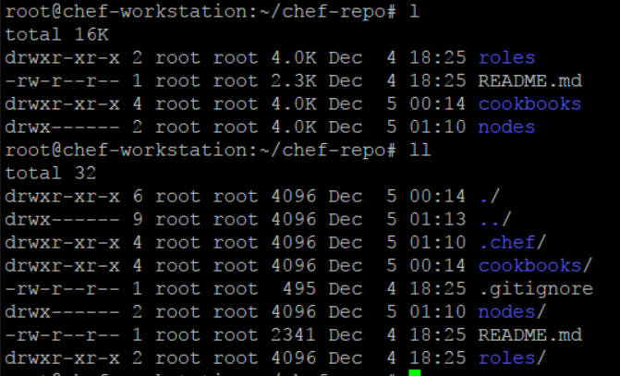

**Knife** is a command line utility which comes under .chef folder. This knife.rb file contains the knife configuration like chef-server url, client keys to do the communication between workstation and chef server.

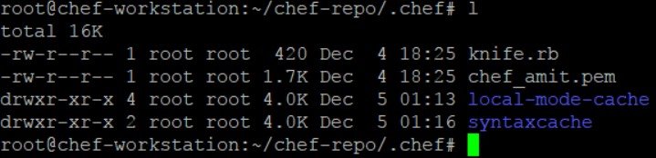

Knife.rb look like below

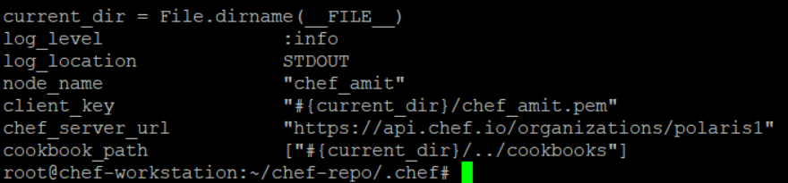

**Lets check how knife works with the help of command knife client list**

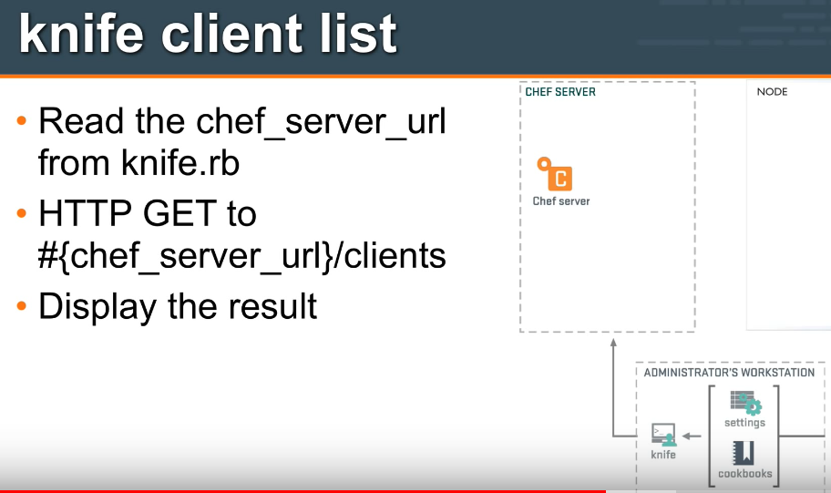

**Ohai** – Ohai is a system profiler tool which gathers the system information about the node and makes it available to the server. This is done at the time of bootstap.( knife node show chef-client –l or ohai is the command)

**Berksfile** is for dependency management for cookbooks. Consider a case where my cookbook is using a community cookbook from chef supermarket. In this case, first I need to download that community cookbook from supermarket and upload it along with my own cookbook to chef server. Berksfile simplifies this workflow for you. With single command (berks install), it downloads all dependent cookbooks (and their dependent cookbooks -- transitive dependencies) from their respective sources (may be from git repository or from supermarket). With another single command berks upload it uploads all these cookbooks to chef server. You do not have to upload them individually with knife cookbook upload. Role of Berksfile in particular cookbooks life-cycle finishes here.

**metadata.rb** is referred by chef-client while actually converging the node. It uses this file to download all the required cookbooks from chef server (assuming that these cookbooks are now available on chef server by using berkshelf or knife) to the node to successfully complete the chef-client run. Sample metadata file look like below.

Here metadeta can be used for versioning of cookbook as well as chef load only that version of cookbook whatever is mention under version attribute of the metadata.

This cookbook versioning is very important in case of uploading different versions of cookbook on different environments like dev, preprod, prod.

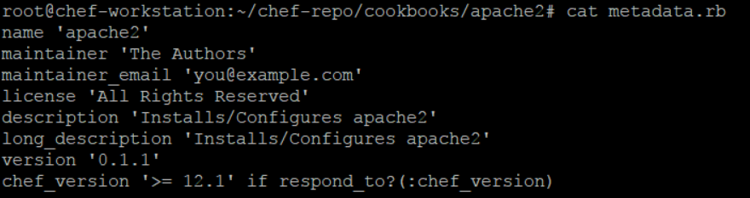

## Data Bags

Chef data bags the file place holders which are used to store the sensitive information like password.

They are created with below command.

Knife data bag create bag name (this will create the data bag on server not on workstation)

This can be downloaded from server to workstation by knife download data_bags

Or other way is to simply create data bags under chef-repo folder like below.

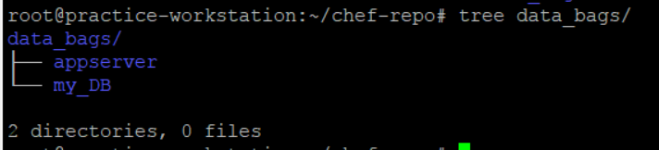

# Wrapper cookbook

If we want to use an ntp cookbook to set a server's time, we can download the community ntp cookbook from Opscode. After downloading, instead of running it directly, we can modify it according to our infrastructure server's time setting.Following is a representation of wrapper cookbooks for more understanding of the concept: We can create another myinfra-ntp cookbook with the following settings and change the attribute settings in the following manner:

myinfra-ntp/attributes/default.rb

default['ntp']['peers'] = ['ntp1.myinfra.com', 'ntp2.myinfra.com']

After this, we can add attributes to the recipes:

myinfra/recipes/default.rb

include_recipe 'ntp'

Now, we can simply run recipe[myinfra-ntp] in our running infrastructure, and the default settings from cookbook will automatically come up.

#### Chef Installation

Once machine is build change the host name in vim /etc/hostname to chef-server

Set the fully qualified domain name (only require for home lab)

Go to vim /etc/hosts

And make the below entry at the bottom of file (here ip address is the ip of same server)

192.168.1.22 chef-server.local chef-server

Download the installation file from the below location

*Wget* [*https://packages.chef.io/files/stable/chef-server/12.17.5/ubuntu/16.04/chef-server-core_12.17.5-1_amd64.deb*](https://packages.chef.io/files/stable/chef-server/12.17.5/ubuntu/16.04/chef-server-core_12.17.5-1_amd64.deb)

*To download the chef development kit for workstation (check the OS and version you are using)*

*Wget* <https://packages.chef.io/files/stable/chefdk/2.4.17/ubuntu/16.04/chefdk_2.4.17-1_amd64.deb>

*Dpkg –i chefdk_2.4.17-1_amd64.deb*

#### Working with Workstation

**Create a recipe hello.rb like below**

file 'motd' do

content 'Hello world!'

end

and then apply it with chef-apply hello.rb now this will create a file name motd.

If you change the content of motd and again run chef-apply hello.rb. it will maintain the state and change the file content to again Hello world! As specified in recipe.

**Now delete this file with**

file 'motd' do

action :delete

end

Now install apache on workstation like below and apply and then run the local host to test

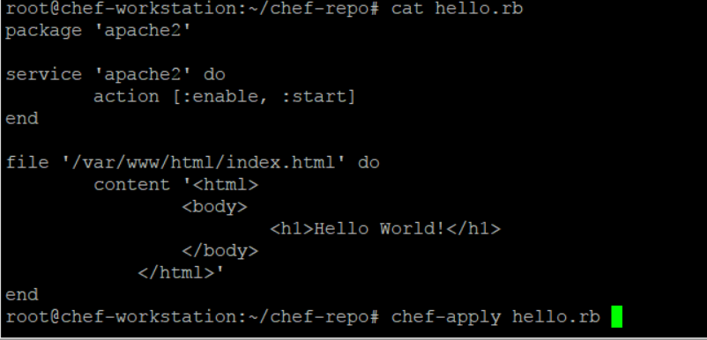

To check the port number

netstat –tulpno

## Sample Cookbook creation

Go to chef directory and fun command - chef generate cookbook apache2-cookbook

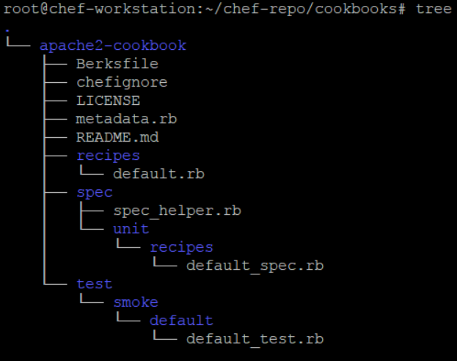

Note – default.rb in side recipe always executed first in cook book.

Generating template – writing big code like template inside recipe.rb file can be a mess incase of big configurations.

So it’s good to have the template separated from recipe code. Run below command to create a template in a cookbook

root@chef-workstation:~/chef-repo/cookbooks# chef generate template apache2-cookbook/ index.html

It includes the template folder like below.

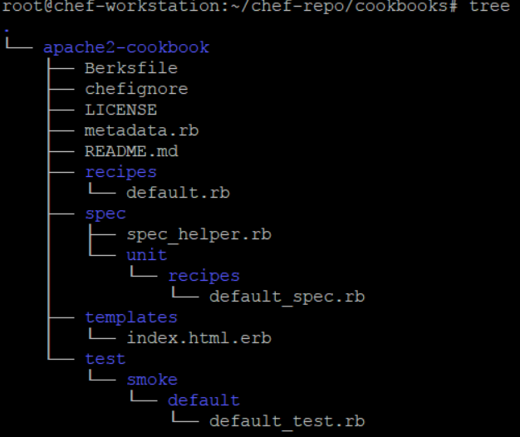

Now change the template like below

vim apache2-cookbook/templates/index.html.erb

Hello World

Change the default recipe like below

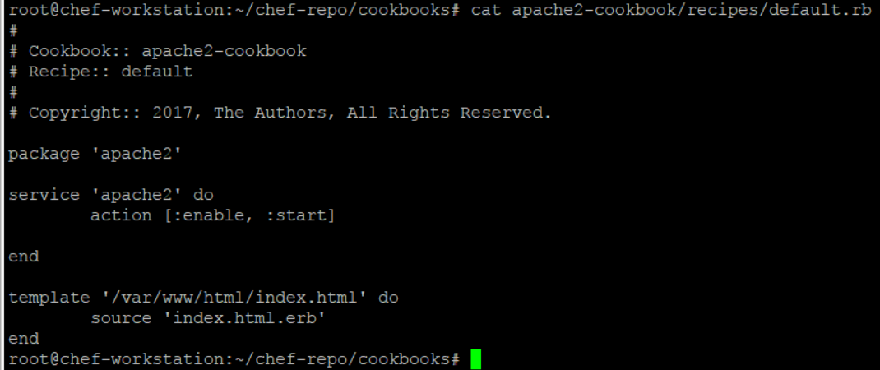

Now run the cookbook like below

root@chef-workstation:~/chef-repo/cookbooks# chef-client --local-mode --runlist 'recipe[apache2-cookbook]'

**Now upload the cookbook to the chef server (internet not standalone)**

Login to manage chef website and create a organisation and download a chef-started key

Now unzip this key chef-starter.zip on workstation. This will create the communication between server, workstation and nodes.

Now upload the cookbook on chef internet server

root@chef-workstation:~/chef-repo# knife cookbook upload apache2-cookbook

**Now bootstrap the node and run the below command on workstation.**

This will install chef client on nodes and pull the cookbook from chef internet server.

***knife bootstrap 192.168.169.6 --ssh-user root --ssh-password 'redhat' --sudo --use-sudo-password --node-name chef-client --run-list 'recipe[apache2-cookbook]'***

# Sample Cookbook 1 – apache2

1. On the workstation inside the /chef-repo/cookbooks, generate the new cookbook with command *chef generate cookbook apache2*
2. It will create a new cookbook apache2 like below
3. 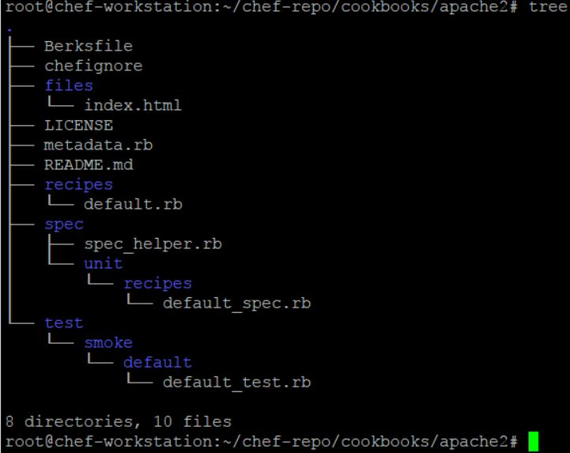
4. *Now edit the default recipe inside the recipe folder*
5. 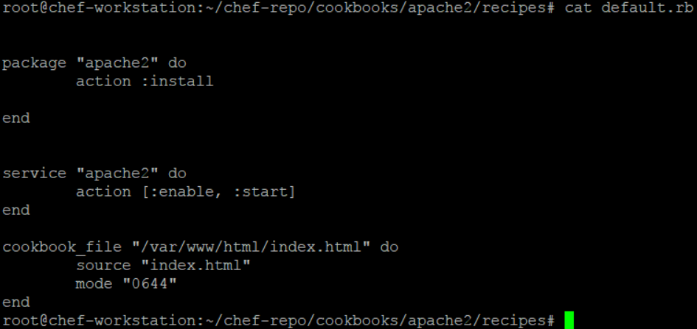
6. *Create a* ***files*** *folder inside the apache2 cookbook and create a index.html file like below*
7. 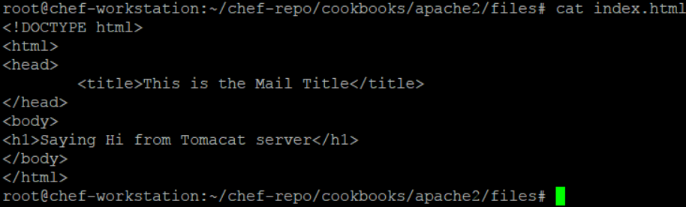
8. *If we want to change the port of apache from 80 to some other then create a separate template like below*
9. 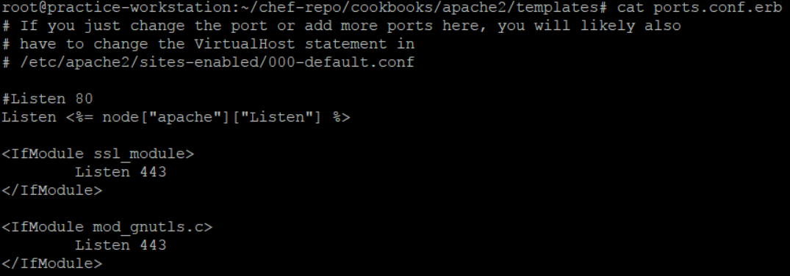
10. *Make change in recipe like below.*
11. 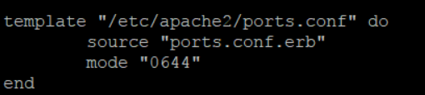
12. *As this is conf file change, make sure to restart the apache service in recipe rather than just start.*
13. *Also add port attribute like below.*
14. 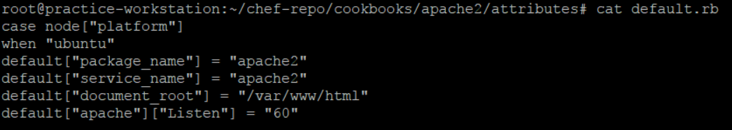
15. *Now upload the cookbook to the chef server like* ***knife cookbook upload apache2***
16. *Before we Pull and apply this cookbook on the node, we need to create a run list on node like below.*
17. *There are 2 ways of creating the run list i.e through server admin console and through command from workstation.*
18. 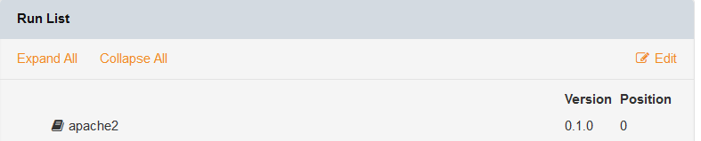 *or*
19. *knife node run_list add chef-client recipe[apache2]*
20. *once run list is created, run the* ***chef-client*** *command from the node machine.*

# Sample cookbook2 – nginx

1. Completed with the same approach below is the recipe file.
2. 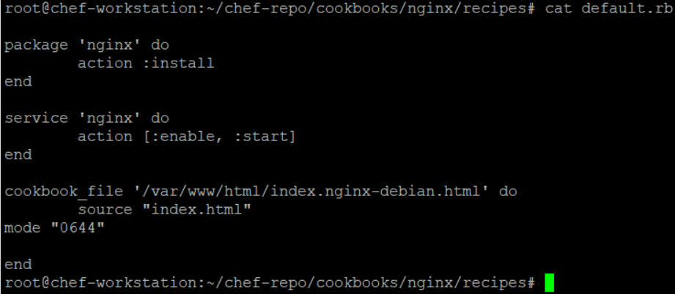

# Sample cookbook3 – apt update

1. Completed with same approach with the below recipe file
2. 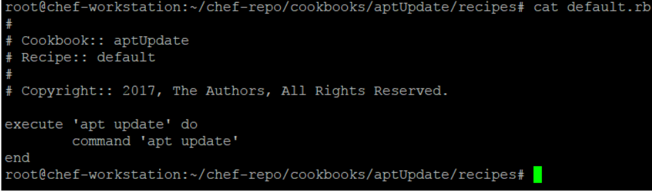

# Sample Cookbook4 – apache4 with template

1. Completed with same approach like apache2.
2. Changed only 2 files like below
3. 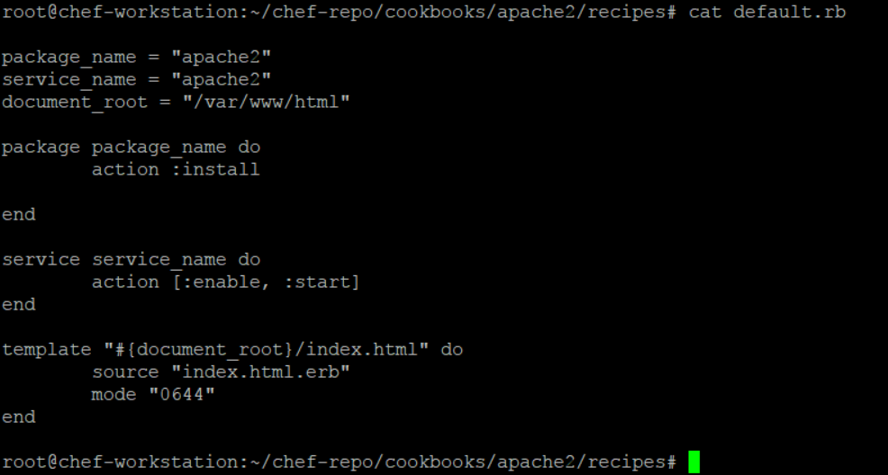
4. 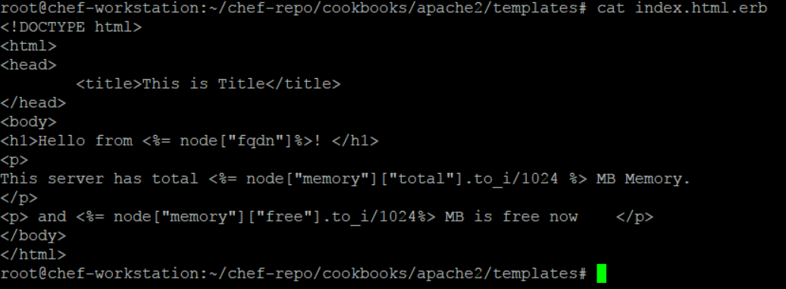

# Sample Cookbook5 – Apache with attributes

1. Completed with the same approach as apache2 with the below changes
2. 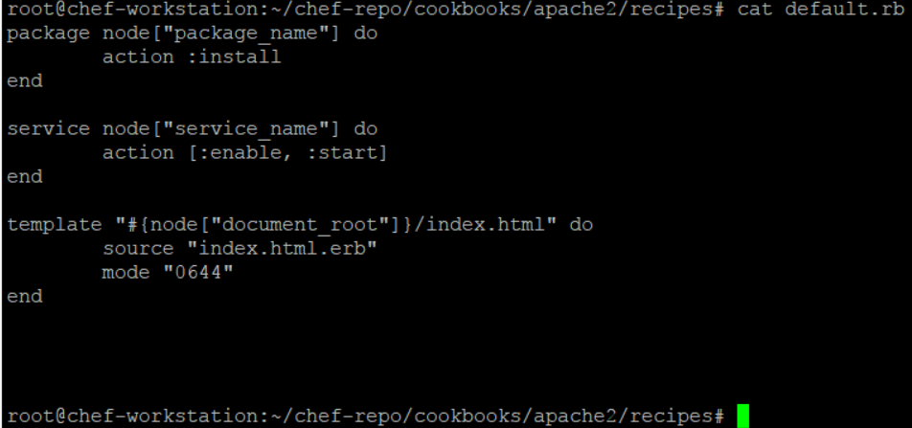
3. 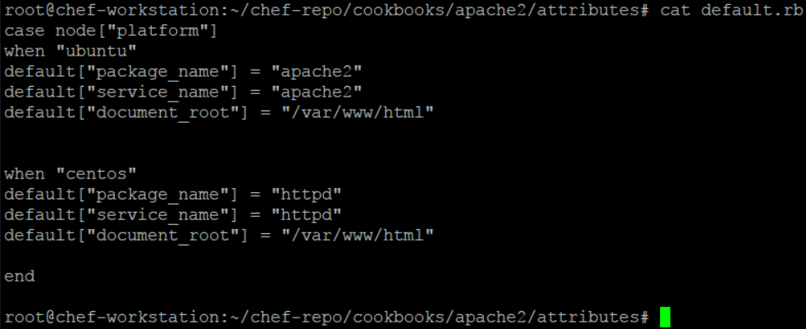

# Sample Cookbook6 – Download chef-client (for cron job setting) from supermarket

1. Download the chef-client and its depending cookbooks with below 2 command (chose any one)
2. knife cookbook site install chef-client (Use this – this is download and install the chef-client and all its depending cookbooks latest versions)
3. knife cookbook site download chef-client (here you will have to manually download and unzip the chef-client and its depending cookbooks in cookbook/ folder.
4. The above commands will connect to supermarket (<https://supermarket.chef.io/>) and download it.
5. Upload all the cookbooks to the chef servers
6. Now update the role like below. Here we have only made the recipe cron of cookbook chef-client, the part of role run_list.
7. 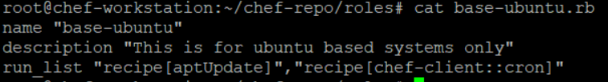
8. Now push this role to the runlist of the node like below.
9. 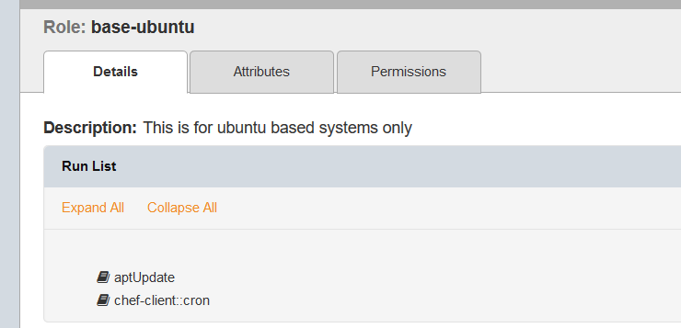
10. 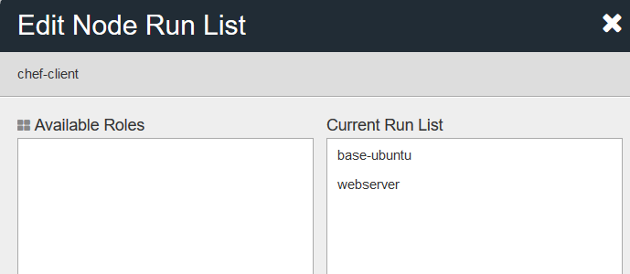
11. Now from the node run chef-client and check the cronjob with crontab -l

#### Difference between Ansible puppet and chef

**Chef** – This is for large infra( 1000+ servers), follows the server agent architect and fast because it make connection and run the command only when the state of the nodes is change, so less overhead.(every 30 min checking of state)

**Ansible** - for small infra (less than 1000 servers), agentless and it’s slow because it always go and create the ssh connections to all the agents and execute command even if there is no change in the state of the nodes. (Every 30 min checking of state). In push mode, Ansible requires a solid SSH connection - even if there is no change in the module, it still go to the nodes and run the commands. SSH communication slows down in scaled environments

# Life cycle of a cookbook

**Generate cookbook in chef-repo/cookbook**

**Write recipe**

**Upload cookbook to server**

**Update run list with this cookbook**

**Run chef-client from node**

#### Chef-Commands

1. To bootstrap node from workstation - knife bootstrap 192.168.169.6 --ssh-user root --ssh-password 'redhat' --sudo --use-sudo-password --node-name chef-client --run-list 'recipe[apache2-cookbook]'
2. Command to generate cookbook – chef generate cookbook cook_book_name
3. To apply a recipe – chef-apply recipe_name
4. To generate cookbook - chef generate cookbook cookbook_name
5. To check the syntax of cookbook – knife cookbook test cookbook_name
6. To upload cookbook - knife cookbook upload cookbook_name
7. To show all the information of cookbook - knife cookbook show cookbook_name
8. To list down all the nodes - knife node list
9. To check particular node information - knife node show node_name
10. To check the system profile of node or all the node configuration - knife node show chef-client –l or ohai
11. To check the system information like memory - knife node show chef-client -a memory.free( here with . you can access all the subattributes as well)
12. To add runlist through command - *knife node run_list add chef-client recipe[cookbook_name]*
13. To remove runlist through command - *knife node run_list add chef-client recipe[cookbook_name]*
14. *To add role in runlist - knife node run_list add chef-client 'role[role_name]'*
15. *To remove role from runlist - knife node run_list remove chef-client 'role[role_name]'*
16. *To upload roles to server - knife role from file role_name*
17. *To show all the roles - knife role list*
18. *To show more info about particular role - knife role show role_name*
19. To upload environment - knife environment from file env_name.rb (ex. Production.rb)
20. To list all environments - knife environment list
21. To show some particular environment - knife environment show env_name ( like dev)
22. knife cookbook site install chef-client (**Use this** – this will download and install the chef-client and all its depending cookbooks latest versions)
23. knife cookbook site download chef-client (here you will have to manually download and unzip the chef-client and its depending cookbooks in cookbook/ folder.
24. to know the latest version of any cookbook on supermarket - knife supermarket show httpd | grep latest

# Downloading cookbooks from chef supermarket

Check the below sample module for full info on this.

**Sample Cookbook6 – Download chef-client (for cron job setting) from supermarket**

<https://supermarket.chef.io/>

# Useful cookbook to have

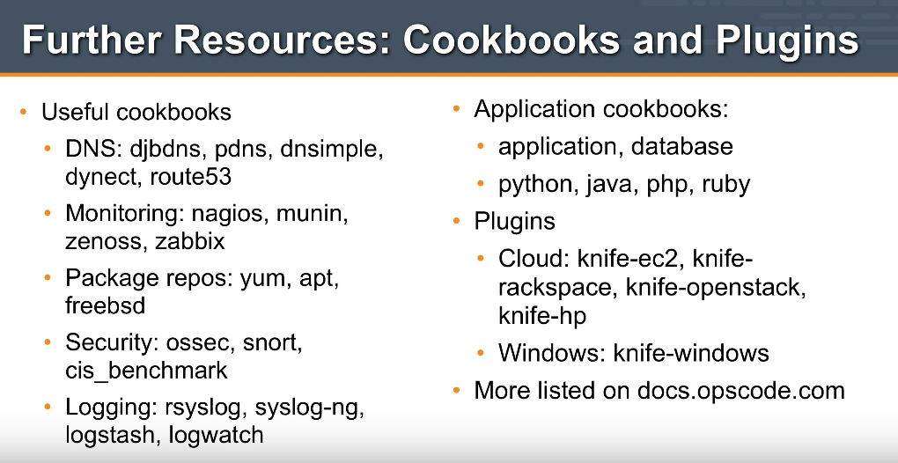

+++++++++++++++++++++++++++++++++++++++++++

END

++++++++++++++++++++++++++++++++++++++++++++

Dockers

Docker is based on container technology it is like vm but there are 2 major short comings in Vm which docker overcome

1. VM is fixed RAM and it resources cannot be utilized.it means if VM machine hardware is 40-50% utilized then rest of the hardware would be total waste but docket take the hardware direct from host and give it back if not utilised.
2. Lift and shift of vm infrastructure to cloud is quite problematic and not straight forward.

## *Dockers facts – We can define as many containers as we want but the aggregate hardware utilization should not be 90% (set 90 to be on safer side other you can go up to 99%)of the base platform*

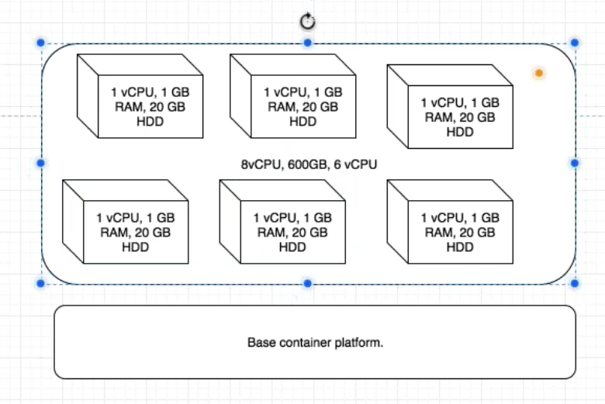

## Docker installation steps

1. Once the ubantu machine is created, update it with *apt-get update –y*
2. Now install some prerequisite for docker like below
3. apt-get install apt-transport-https ca-certificates curl software-properties-common –y
4. Now download the docker key
5. wget <https://download.docker.com/linux/ubuntu/gpg>
6. Now add the gpg key with: *apt-key add gpg*
7. Now add the below repository in last line in: *vim /etc/apt/sources.list*
8. deb [arch=amd64] https://download.docker.com/linux/ubuntu xenial stable
9. Now do: apt-get update
10. Now install the docker community edition with: *apt-get install docker-ce –y*
11. Docker installed now and checked the docker version with: docker –version
12. Now do a connectivity check with docker hub as below
13. docker run hello-world
14. 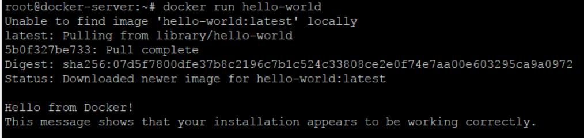

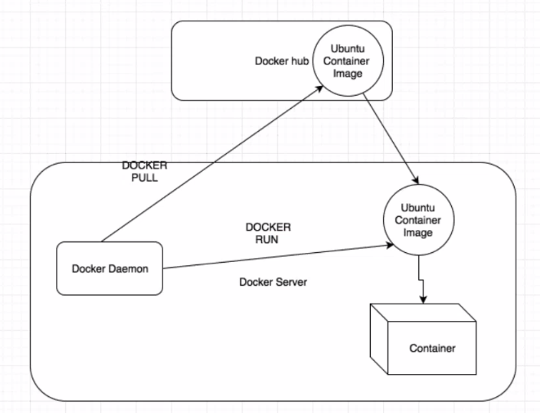

## Docker images and container working

Create few images with the help of docker pull centos/debian command like below

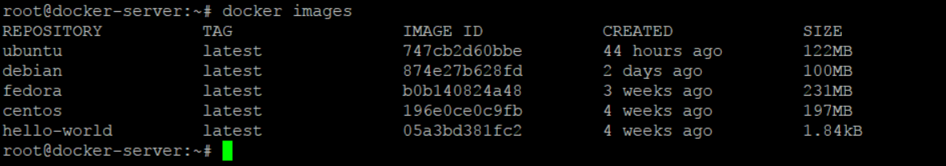

Now create a container with the help of image Ubuntu in interactive mode

docker run -ti Ubuntu

the above command will create the container and go inside it

always do the apt update inside a new container as a first thing

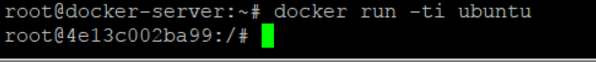

Important – The container and the base machine share the same pool of resources which means whatever the capacity of base machine (RAM, HD), container will also have the same.

The is no pid for the docker containers, so you cannot kill a container from outside like base machine. The only way is to do it from inside the container. Only the docker deamon PID (dockerd) is exposed to base machine.

## Commit the container and create image out of it

First exit from the container with the exit command and from base machine now check the image id using docker ps –a

1. Now commit the container image using command
2. docker commit -m "created my container" -a "Amit" 998aa9892882 dockeramit/myimage
3. Note – here dockeramit is the userid for hub docker account
4. Now login to the dockerhub using docker login command and push this image to docker hub cloud.

## Pushing and pulling the image from docker hub cloud

1. docker push dockeramit/myimage
2. 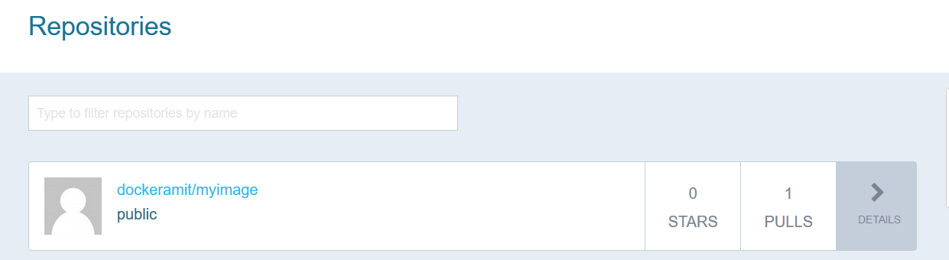
3. Now remove the image from command (optional just for leaning purpose)
4. docker rmi dockeramit/myimage
5. Now when image is removed from base machine, you can pull it from the docker hub account(which we pushed above) with below command
6. docker pull dockeramit/myimage
7. Now you can run this image with command docker run -ti dockeramit/myimage

## Docker Commands and Usage

1. To list the Images: docker images -a
2. Docker current running containers: docker ps –a
3. 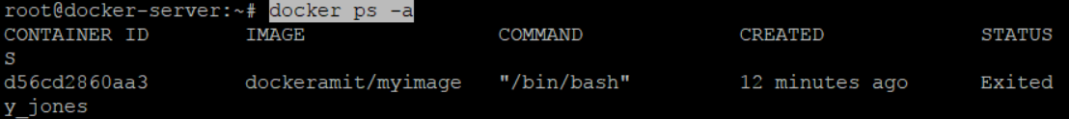
4. To remove the docker images: docker rmi Ubuntu
5. To remove all the images at once: docker rmi -f $(docker images -q)
6. To remove docker containers at once: docker rm -f $(docker ps -aq)
7. Create container out of image in background: docker run -d Ubuntu
8. To create a container from image: docker run -ti Ubuntu (note this will take you inside container so you will have to exit it)
9. To create a container in background and in running state: docker run -ti -d Ubuntu
10. 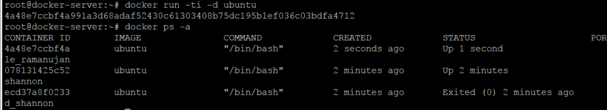
11. If container is using high CPU or another hardware then to release the hardware memory we can pause it: docker pause 4a48e7ccbf4a
12. To unpause: docker unpause 4a48e7ccbf4a
13. To start a stopped or exited (as exit command inside the container stops it) container: docker start ecd37a8f0233
14. To go inside the already running container: docker attach ecd37a8f0233
15. To exit container without stopping it: clt + p + q
16. 
17. To create a container with customised name: docker run -ti -d --name amit_container Ubuntu

## Docker Networking

There is 3 types of networking

Bridged

HostOnly

None

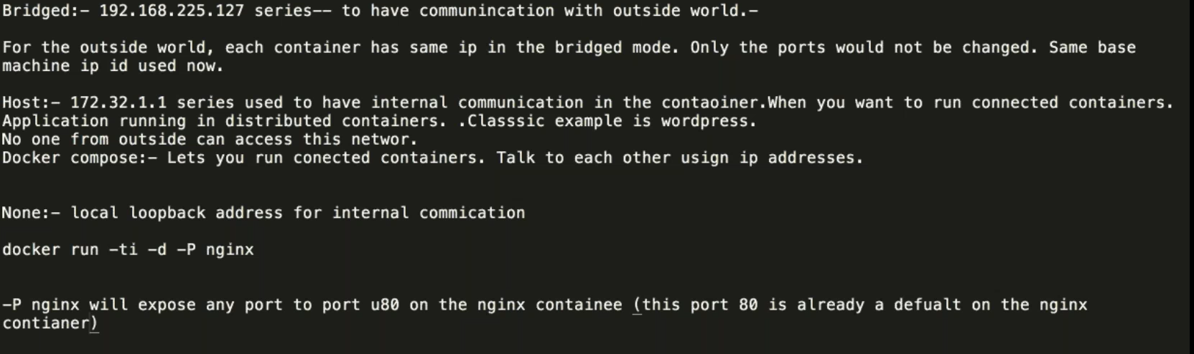

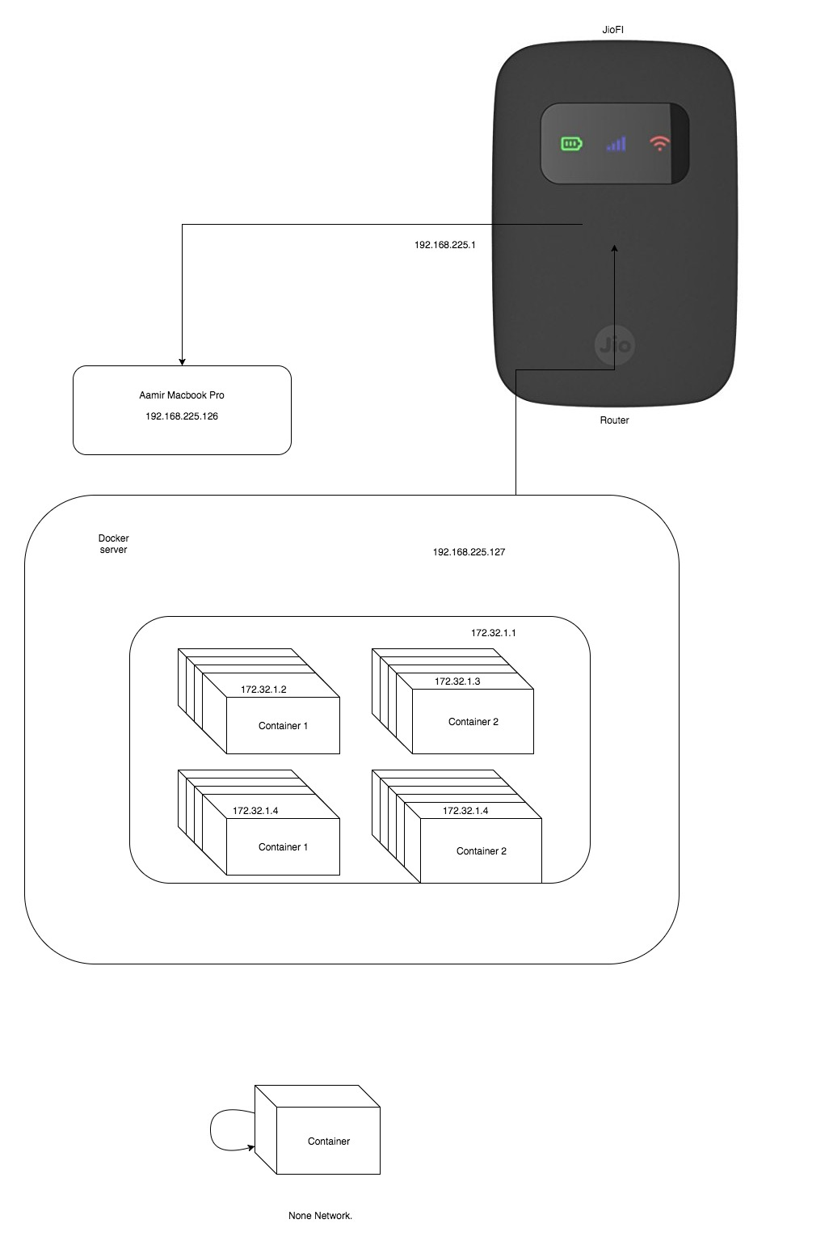

# Ports

Docker ports

**Free Ports (Useful for local development)** – **docker run –P nginx** here docker assigned random port to the nginx container(and keep on incrementing it incase you run multiple) and would expose that to the docker base machine and this can be check using docker ps –a .

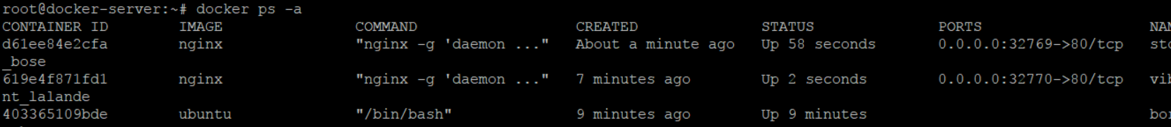

**Binding ports** - **docker run -d -p 81:80 nginx** here everything remains same just that port is assigned by user. You can assigned multiple ports like this docker run -d -p 80:80 nginx

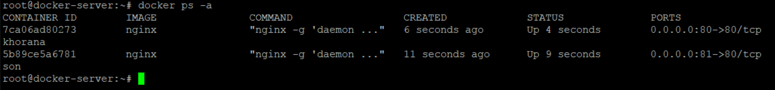

# Volumes

There are 2 types of folder volume creation in docker and one of them is called data container

### Data Containers

There are 2 types of folder volume creation in docker and one of them is called data container. In this we create a directory and we expose it to all the container on that base machine. So any container which is created, will have that mounted folder and all of its global data(which means all the data from all the containers in this mount persist and do not lost even if the containers are destroyed). The data will be lost only if main data container is destroyed.

Command to create data container

docker create -v /var/opt --name datacontainer ubuntu /bin/bash



Now other container can be created and mounted to this container like below

docker run -t -i --volumes-from datacontainer ubuntu /bin/bash



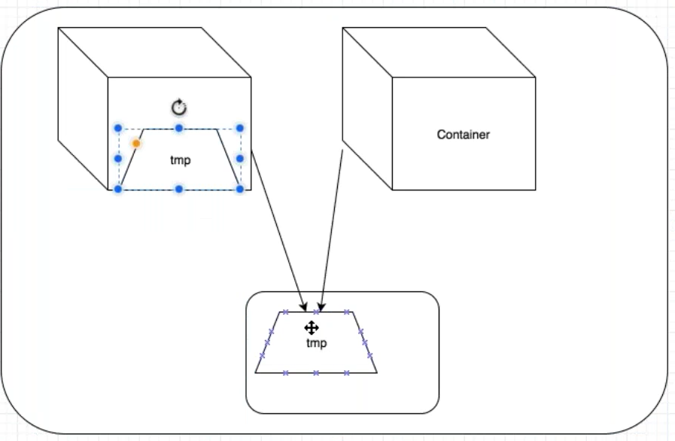

### Persist in Base machine

First create a folder inside the base machine (say mkdir nginxlogs) and then run the below command.

**To create a nginx container and to have log from /var/log/nginx persisted in base machine**

docker run -d -v /root/nginxlogs/:/var/log/nginx -p 5000:80 -i nginx

**To create a normal Ubuntu container and have the log persist in base machine**

docker run -d -ti -v /root/nginxlogs/:/var/log/nginx ubuntu /bin/bash

Docker Swarm cluster

In the swarm cluster, any container can be accessed using any machine(master or worker) IP address which means this whole cluster works as single piece of machine.

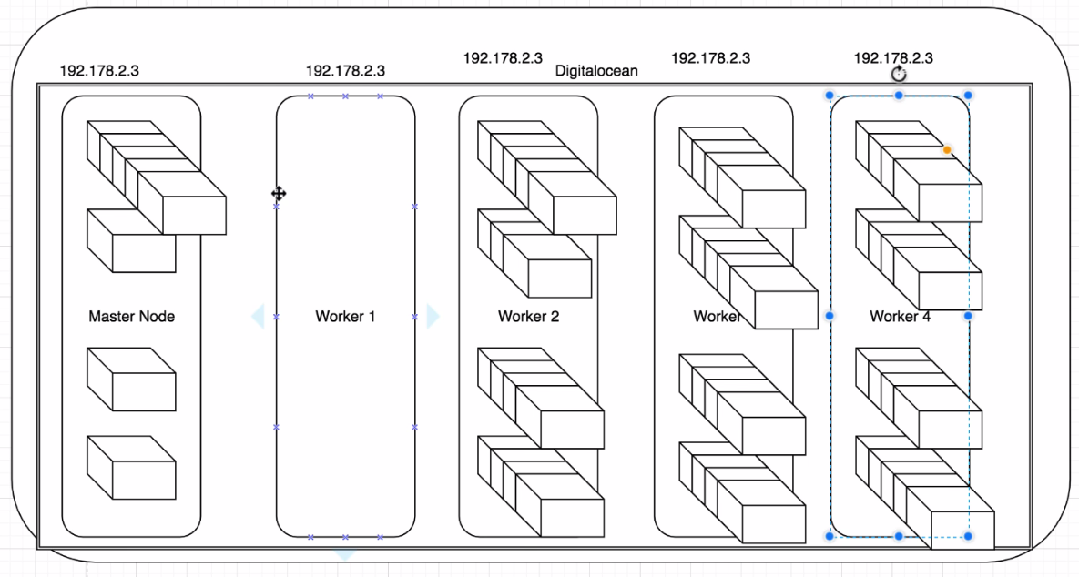

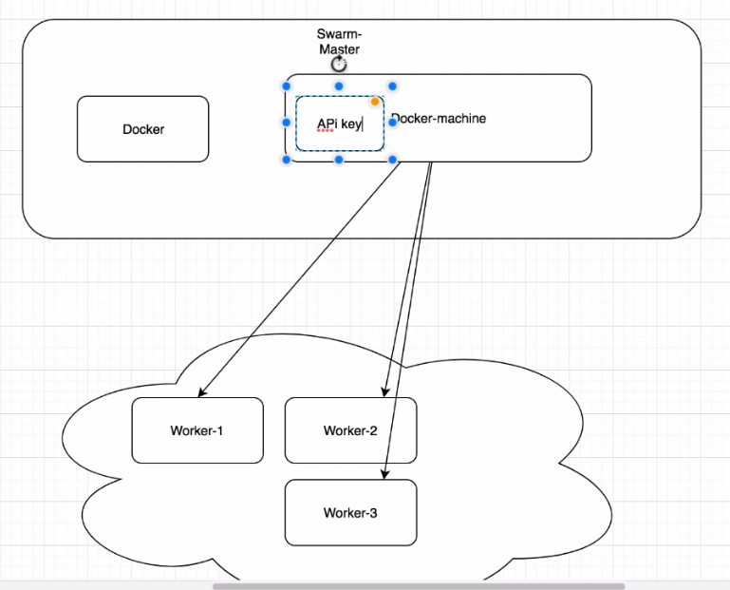

# Swarm Master

Swarm master server need to have the docker and docker master installed in it.

Follow the below steps

1. Install the docker on the swarm master server
2. Install the docker master on the server now by following the below steps
3. curl -L https://github.com/docker/machine/releases/download/v0.12.2/docker-machine-`uname -s`-`uname -m` >/tmp/docker-machine &&
4. chmod +x /tmp/docker-machine &&
5. sudo cp /tmp/docker-machine /usr/local/bin/docker-machine
6. now check the docker-machine –version to check if it working.
7. Now docker machine will need the API key so that it could talk to cloud server (digital ocean, AWS) for getting the machine created automatically.
8. Go to the digital ocean cloud and create a key like below
9. 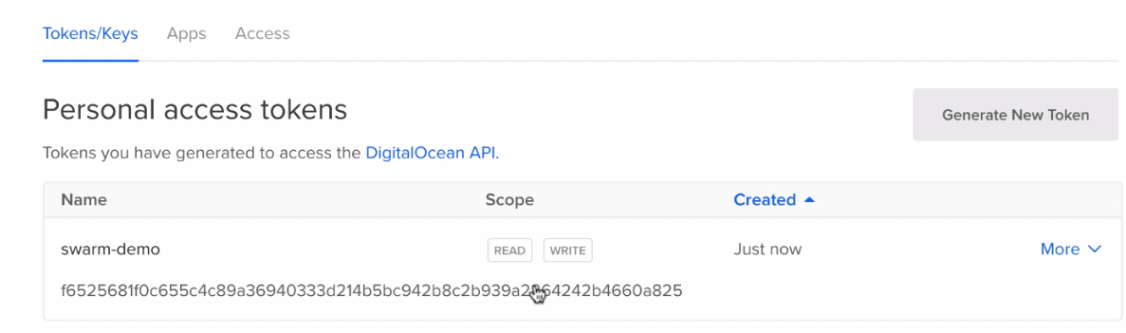
10. Now copy this key (as it will be visible only once) and save it in environment variable on master server like below.
11. 
12. Now go ahead to create a node one machine with the help of docker-machine
13. 
14. Once this is completed, create node 2 and node 3 as well.
15. Initialled the Swarm cluster, Once all the 3 node machines are created
16. Docker swarm init –advertise-addr ip_adress_of_swarm_server
17. 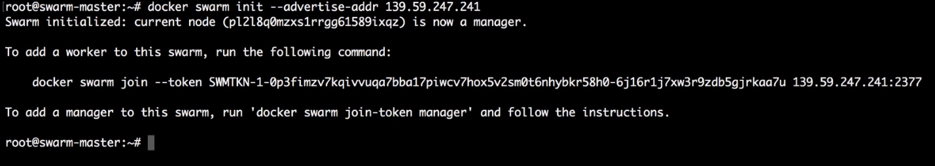
18. Now since cluster is initialled , now join the other machines to this cluster.
19. Now ssh to the other machines like below and run the above one time command to bring them in cluster
20. 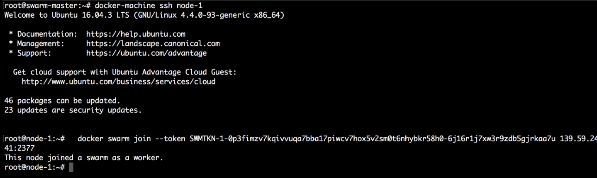
21. Now exit from this node 1 and ssh to node 2 and node 3 and join them as well.
22. 
23. Now check the cluster node with docker node ls command.
24. Now create an nginx server on the master server with below command.
25. Docker service create –p 80:80 –name webserver nginx
26. 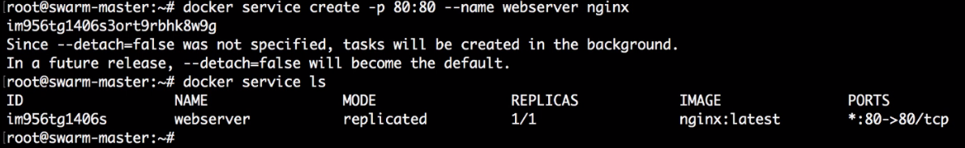
27. The above command means only 1 container is running with nginx and this will be available across all the cluster machines(check by launching the IP addresses of all)
28. Check status with docker service ps webserver
29. Now scale this webserver from 1 to say 50 containers like below
30. Docker service scale webserver=50
31. 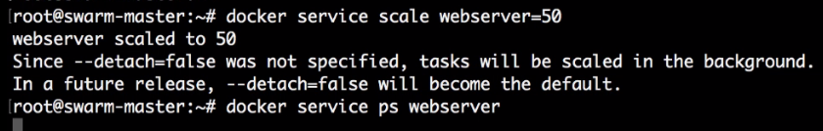
32. Check with docker service ps webserver and you will see all of them are distributed equally.

++++++++++++++++++++++++++++++++++++++++++++++++

END

++++++++++++++++++++++++++++++++++++++++++++++

Maven (apache)

Maven is basically a build tool (like ant, gradle) which is used to resolve the following problems that arise during the development of any project.

Common problems of projects

1. Multiple jars – when project is developed on some framework says spring then it requires certain jars during compile time and deployment time. Maven does this for us.
2. Dependency and version – Many jars have dependency on one another, maven resolve those dependencies.
3. Project structure – it helps in maintaining the correct directory structure for example for some web application we need to have WEB-INF, libraries.
4. Build, publish and deploy

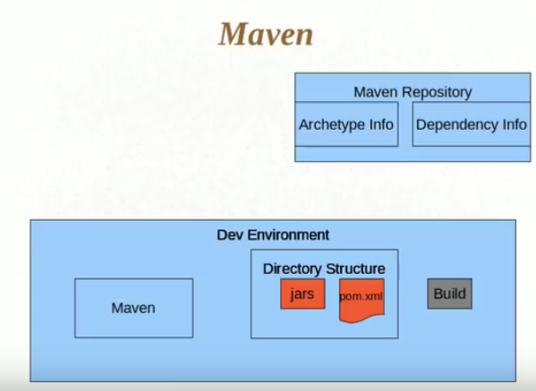

## How it works

Suppose we have to create a project based on maven archetype then first create a folder and inside a folder say mvn archetype:generate

Now this will show deferent archetypes and you can choose from there. Based on the chosen archetype, maven will create the folder structure also it will automatically download all the depending jars from maven repository.

Archetype – These represent the project model (ex. normal java project, spring, struts, hibernate project) and based on selection it creates the standard directory structure automatically

## POM.xml

It’s like a configuration file for maven where all the jar dependencies, folder structure, information required to build the code, scope, project packaging are defined.

Here

**group id** = package name(com.core.packagename)

**artifact id** = project name

**packaging** = jar,war,ear( based on project chose during archetype)

If you want to include new jar dependency(ex. Log4j) here in pom then search for pom repository dependency in Google for log4j and copy paste that dependency code block below.

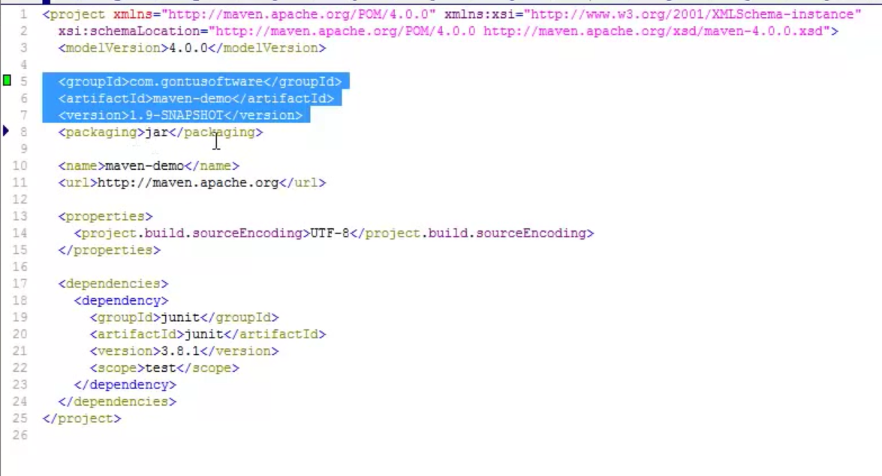

**PMD (Programmatic mistake detector)** – This is automatic software which we plugin in pipeline second project(after checkout) to check the mistakes done by developer in code (like empty catch block etc.)

**Junit** - This is plugged in to do the junit testing after PMD build

**Coberture** – It checks the java project after Junit to test how much code is access by unit test